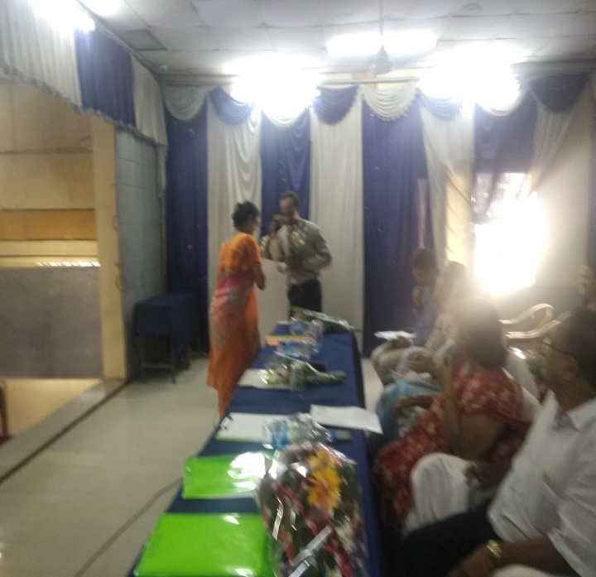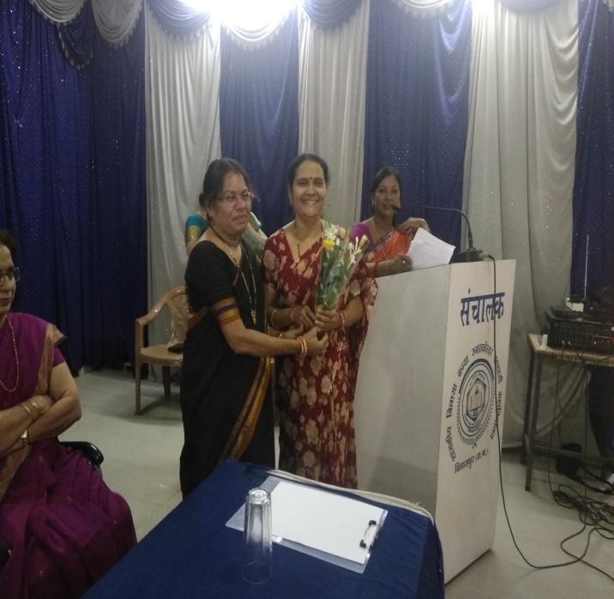
Dr. Pushpa Bhandari welcoming Dr. D. Meshram Dr. Shukla welcoming Dr. Sharda Dubey

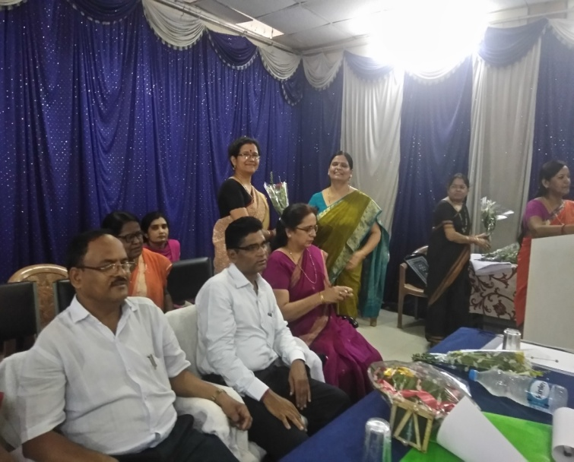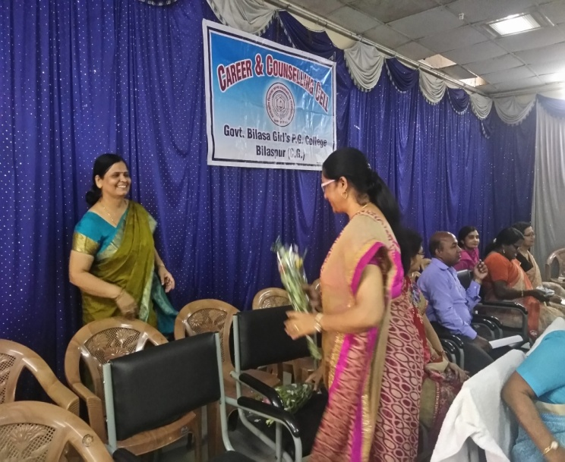
Dr. Archana Singh welcoming Dr. Kaveri Dabhadkar Dr. Shashi Gupta welcomed by Dr. Singh.

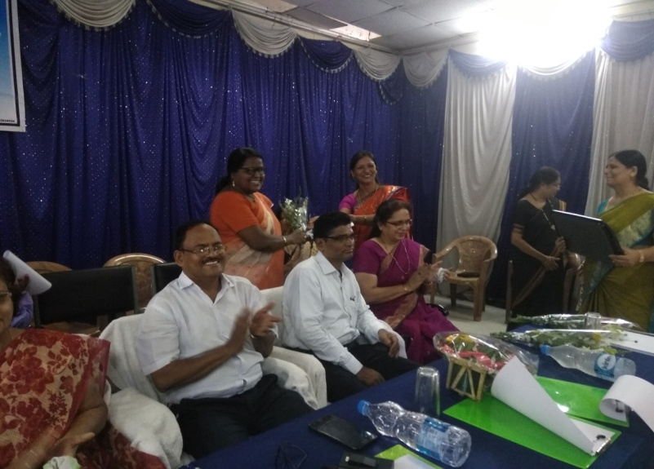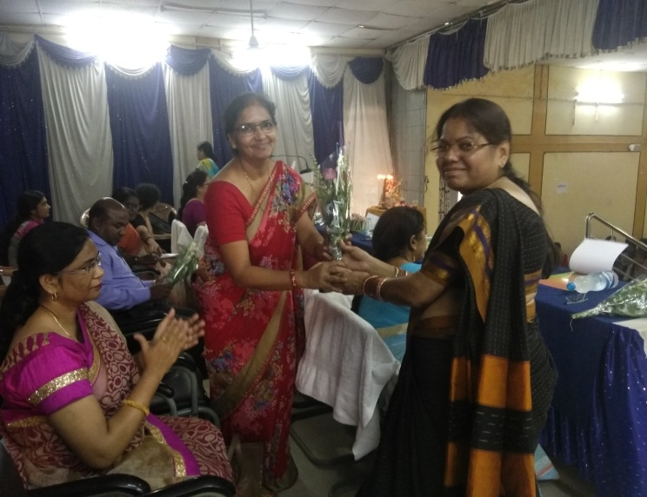
Dr. Sharda Kashyap welcomed by Dr. Bajpei Dr. Sangeeta Shukla welcoming Dr. Rajni Singh

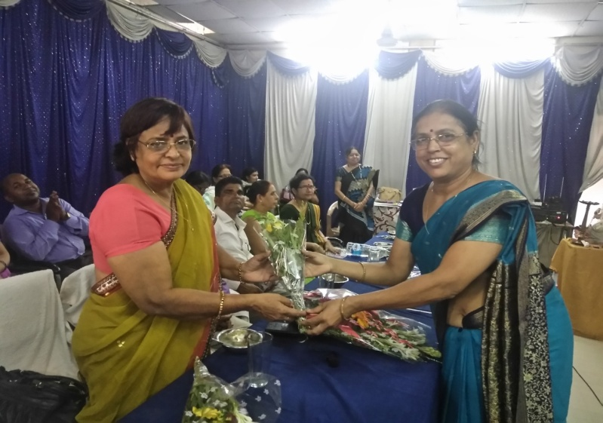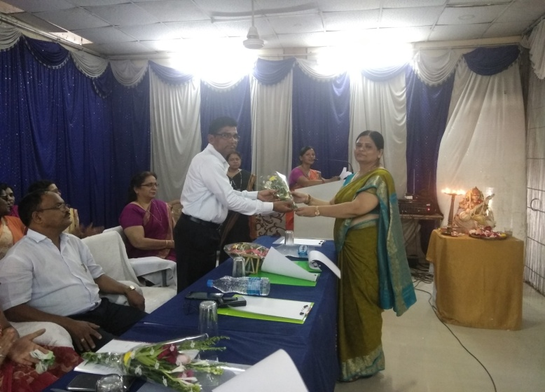
Dr. Kiran Vajpai welcomed by Dr. Pushpa Bhandari Dr. Archana Singh welcoming Dr. D. S. Thakur

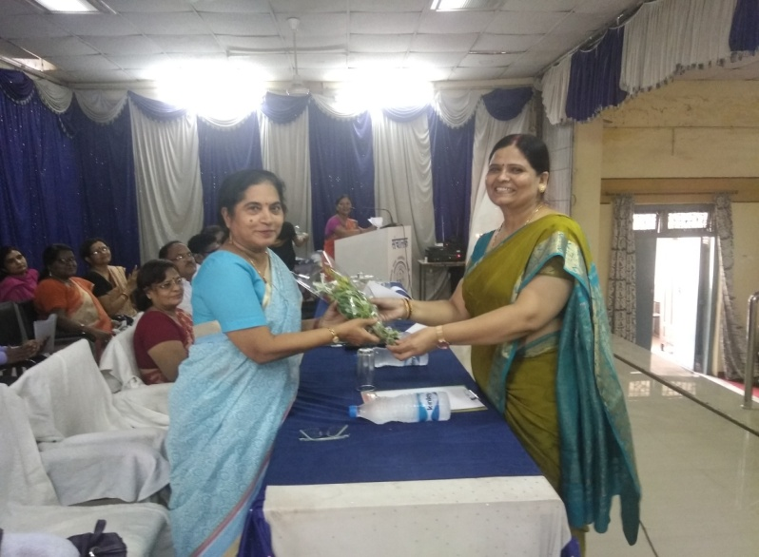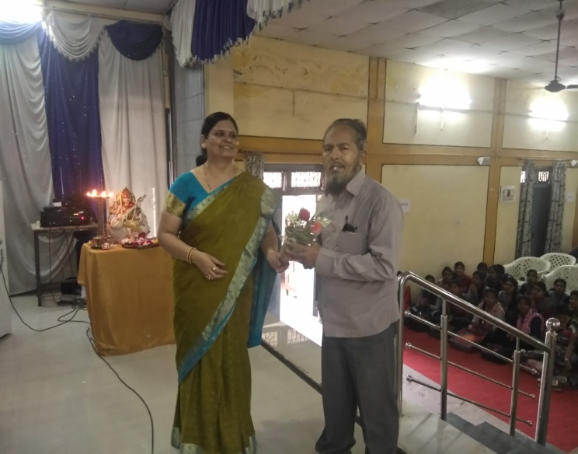
Prof. Kusum Lata Tiwari welcomed by Dr. Singh. Dr. Archana Singh welcomes Dr. Khalid Ali

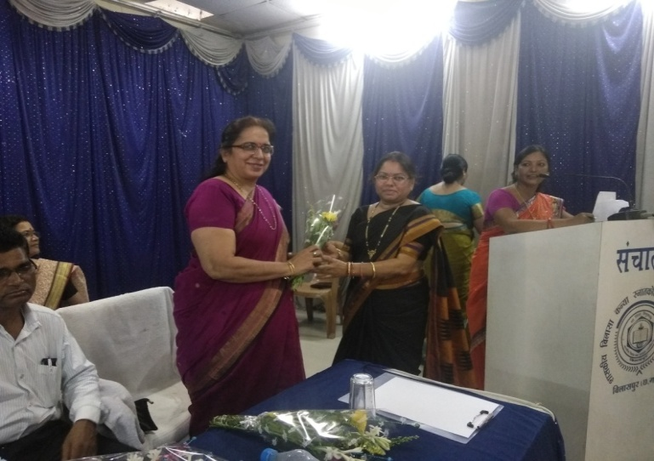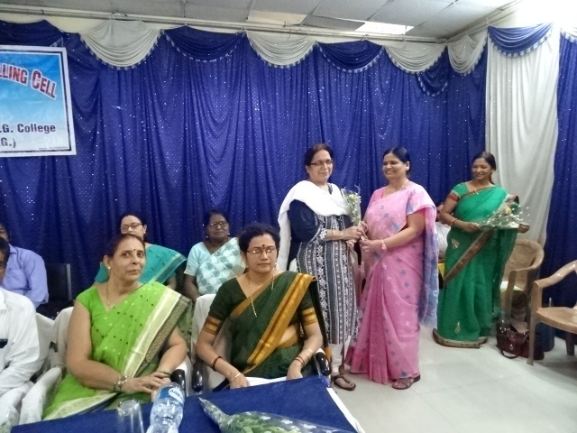
Dr. Ruby Milhoutra welcomed by Dr. Shukla. Dr. Archana Singh welcoming Dr. Ruby Milhoutra

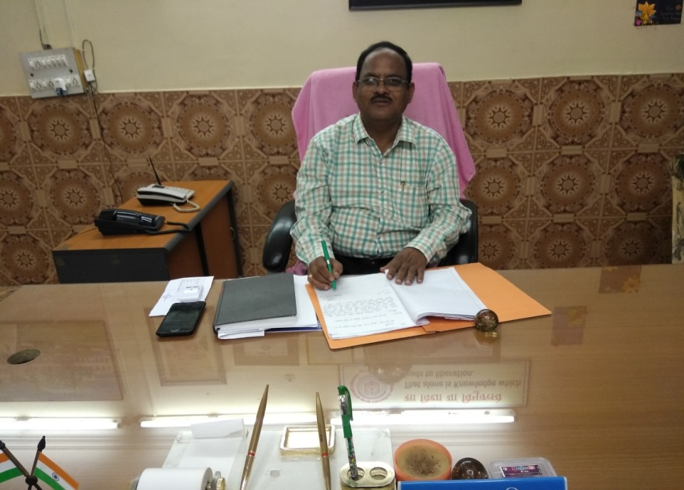
Dr. Shyam Lal Nirala
Principal & Patron

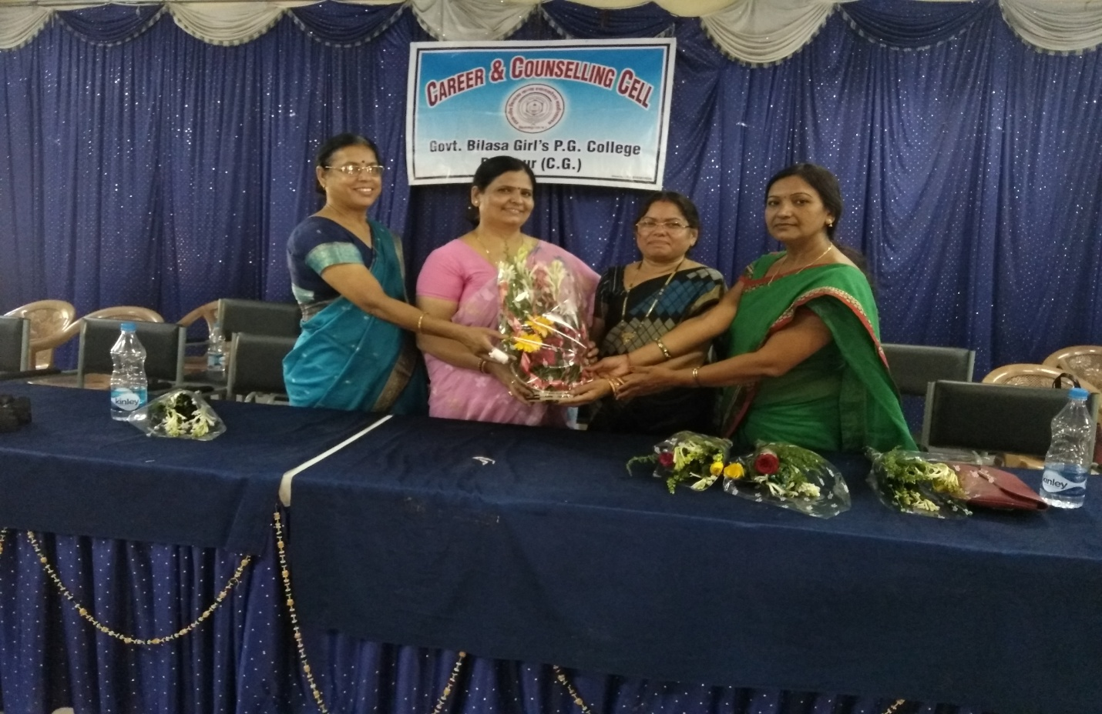
Career & Counseling Cell
Since 2012
Left to Right- Dr. Pushpa Bhandari, Dr. Archana Singh, Dr. Sangeeta Shukla &
Dr. Manju Madhuri Bajpeyi

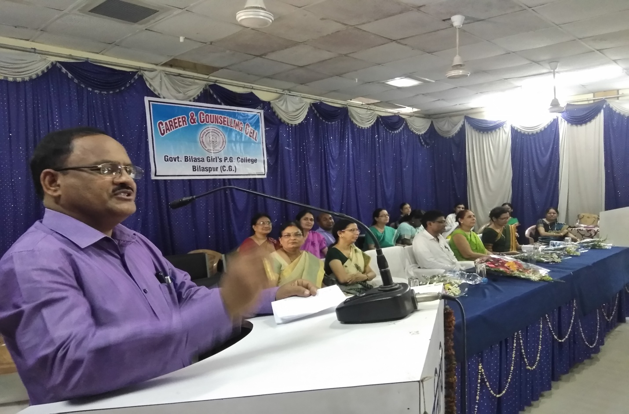
Principal Dr. S. L. Nirala addressing the students of First Semester Under
Graduate in his maiden speech.

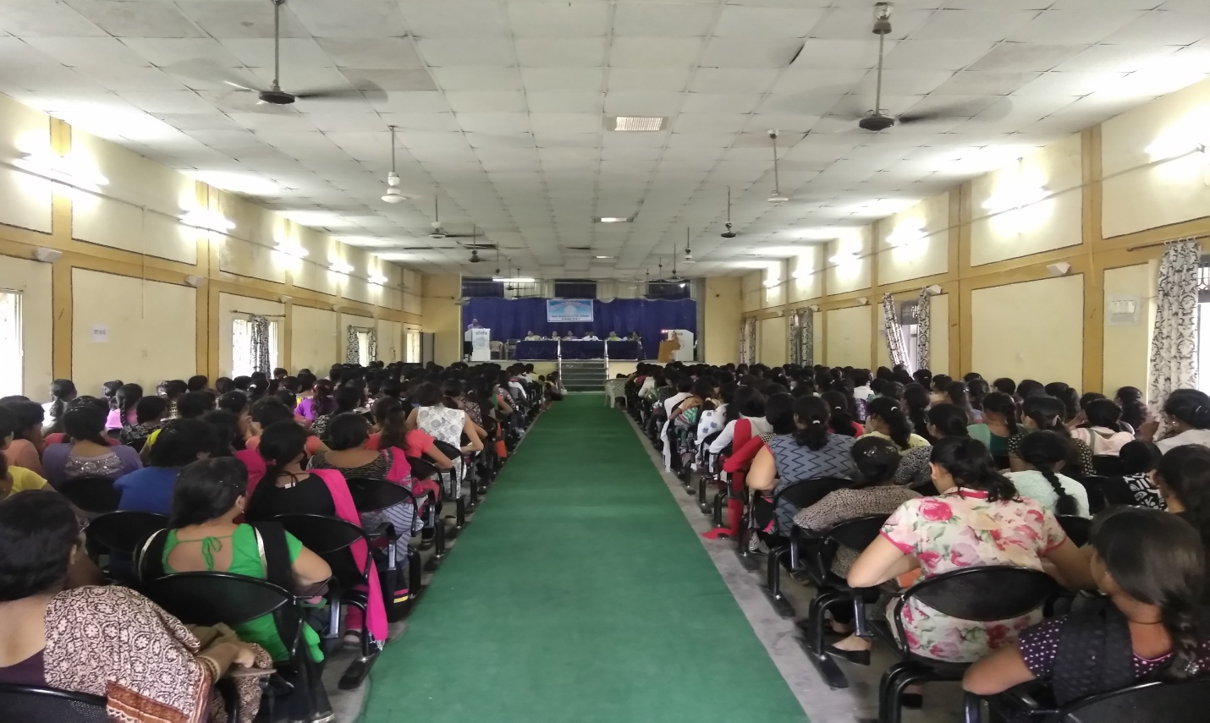
Gathering of First Semester’s Students in the Induction Programme

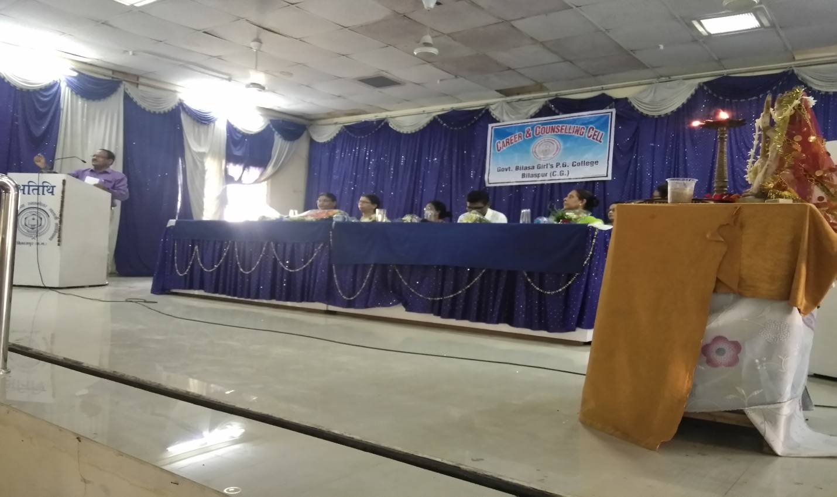

Dr. S. L. Nirala Honourable Principal has addressed to the students of First Semester. Principal Sir exhorted the students to follow the path of Eklavya in their lives. All the students are equal only their hard work and disciplined lives make them special. Education is the only medium to achieve success in life. He also invoked students to always respect their parents, teachers and elders and teachers are their guides and mentors whenever students feel any problem or difficulties they should not hesitate to seek help from us.
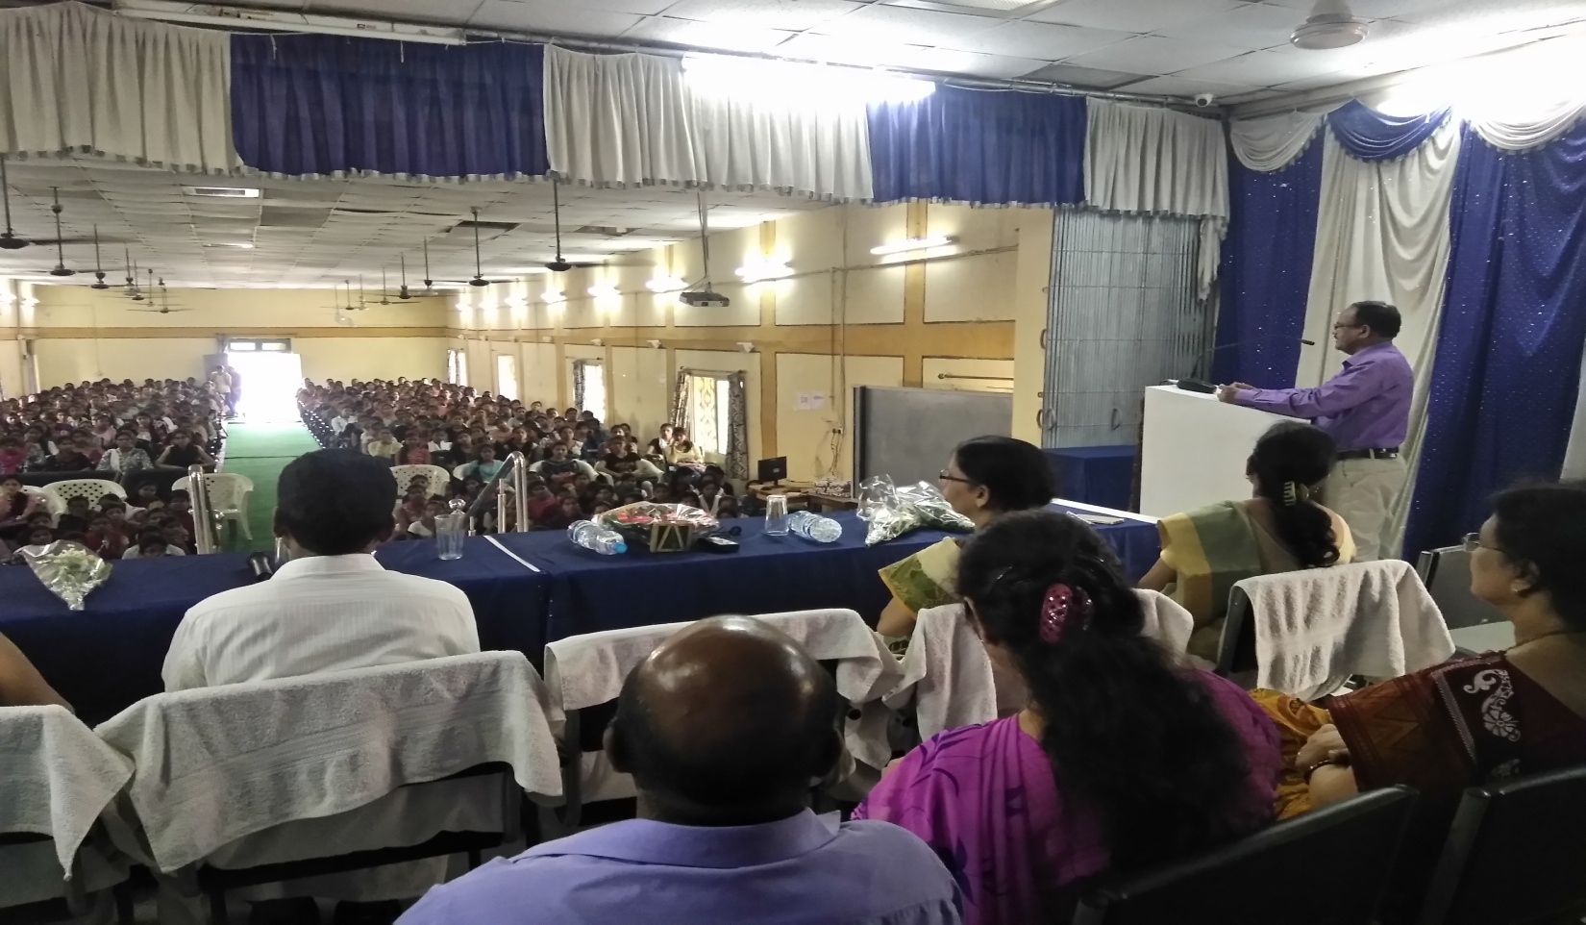
Dr. S. L. Nirala, Principal addressing to the gathering of First Semester’s Students

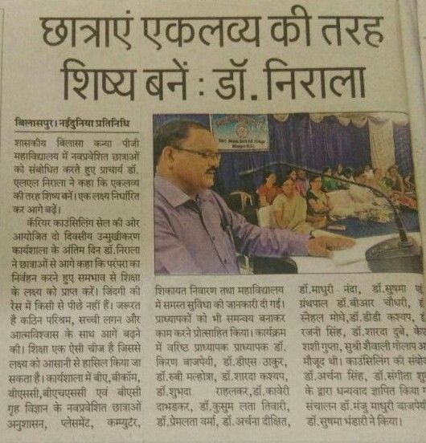
“Nai Dunia” News Paper’s News: Dated – 25th August, 2017

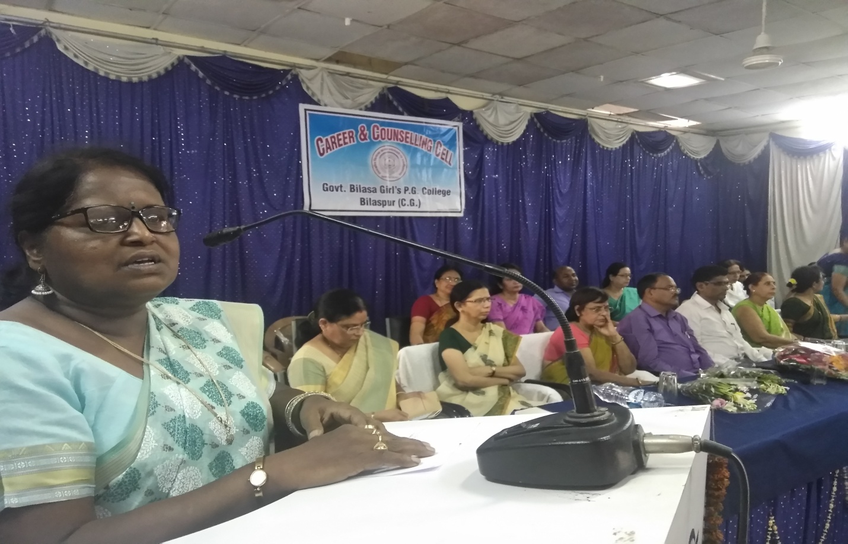
Dr. Sharda Kashyap Sports Officer addressing to the students of First semester

Dr. Sharda Kashyap, Senior Sports Officer of the college has informed the students
about the available facilities in the college. The college has a very good track record
in the in the Sports arena of this region. Many students have been selected in National and State level competitions. There is a big playground in the college campus. Coaching Camps of Kabaddi, Kho-kho, Hockey, Football, Basketball, Table-Tennis, Badminton, Cricket etc. are organized by the college.

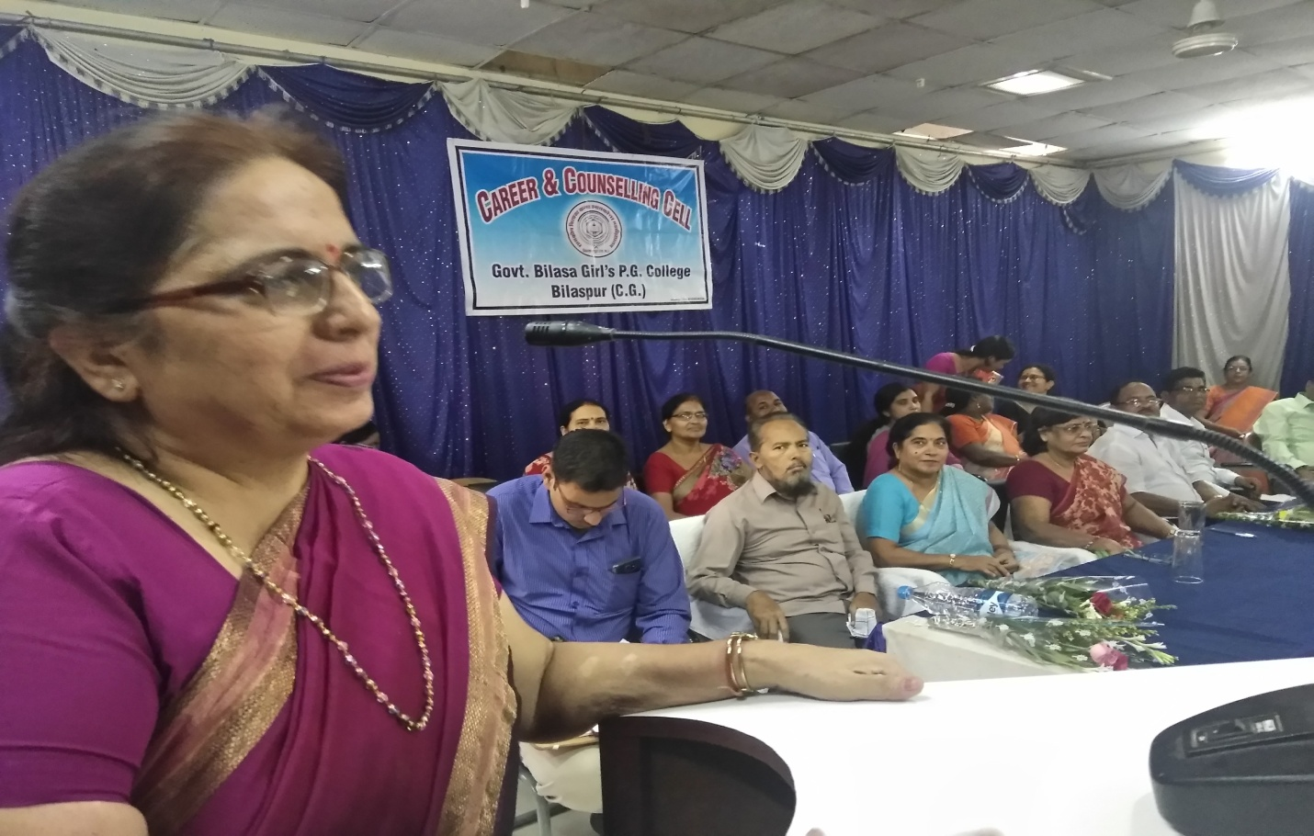
Dr. Ruby Milhoutra Convener- Parent-Teacher Yojna and Grievance Redressal Committee

Dr. Ruby Milhoutra has informed the students about Grievance Redressal Cell which
is constituted to resolve various grievances of the students, faculty members and
office staff of the college.

Dr. Milhoutra has also made the students aware of Shikshak-Abhivavak Yojna. For
50 students, one teacher is appointed as Abhivavak (Guardian) who takes the
Feedback and suggestions from the students and their parents and takes necessary action to rectify their problems accordingly.

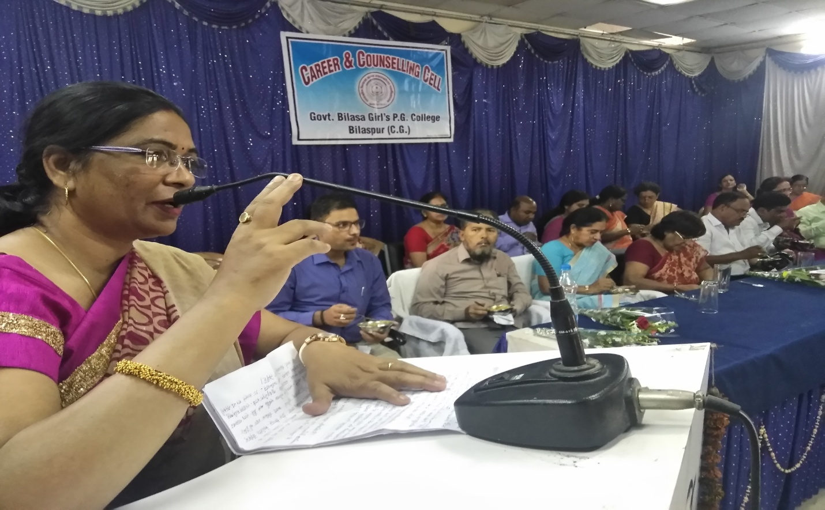
Captain Dr. Shashi Gupta, NCC Officer addressing the students

National Cadet Core (NCC), the Second Line of Defence, is the only Senior Women
Unit in the district. Striving hard to maintain “Unity and Discipline” is the motto of NCC.
The cadets of the college have achieved commendable positions in the National and
State level. The college has two units with the total strength of 107 cadets. The Unit has
recently been attached to the 7 C.G. Battalion. The cadets of the college have been
selected in various camps like Trekking, ATC, CATC, RDC, NIC, DCAT etc. and have proved
their ability to their best and bagged prestigious positions and awards. NCC helps in
developing overall personalityof the students in a planned and disciplined way.

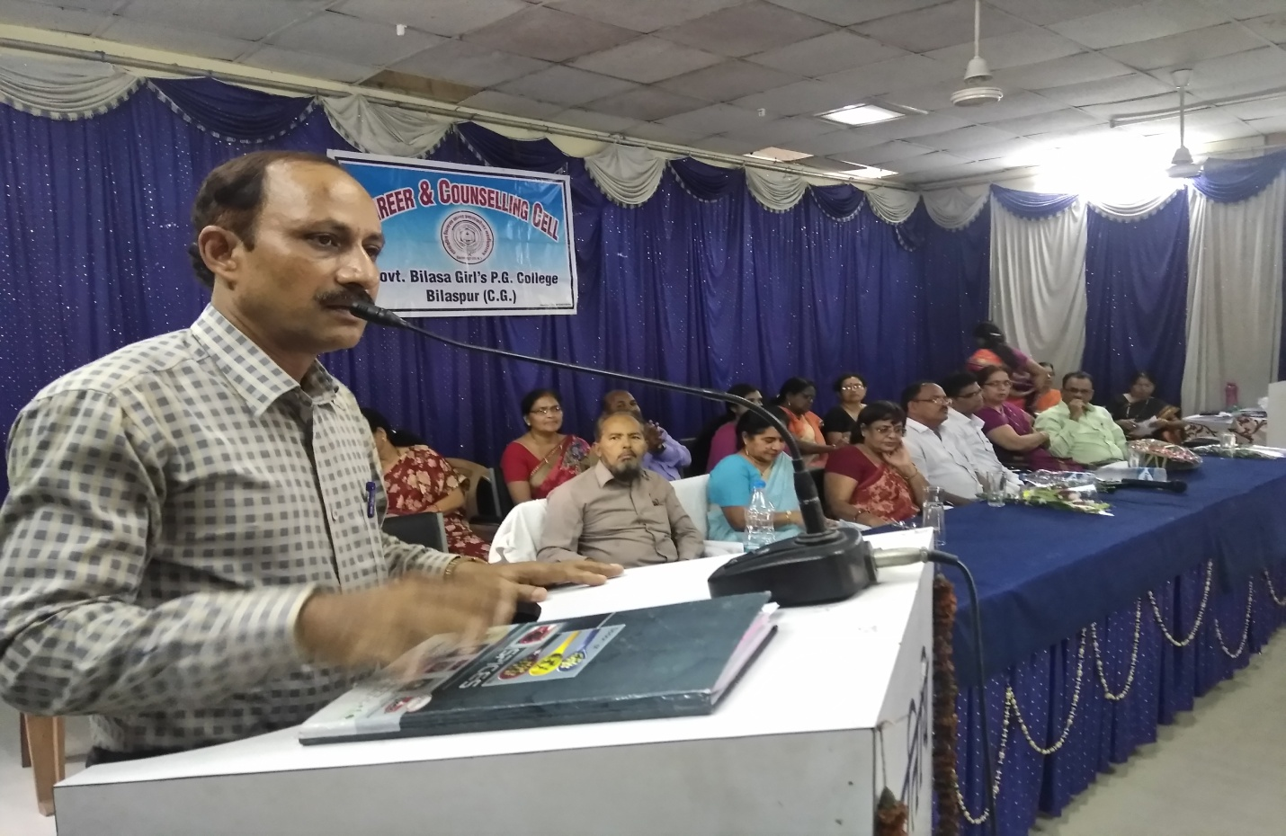
Dr. D. Meshram Convener – Incharge Scholarship Scheme of Government.

Dr. Meshram talked about the Scholarship Scheme running in the college. Central
Govt. and C.G. Govt. provide scholarships to various categories of students in the
college. In this regard notifications are circulated among the students from time to
time.

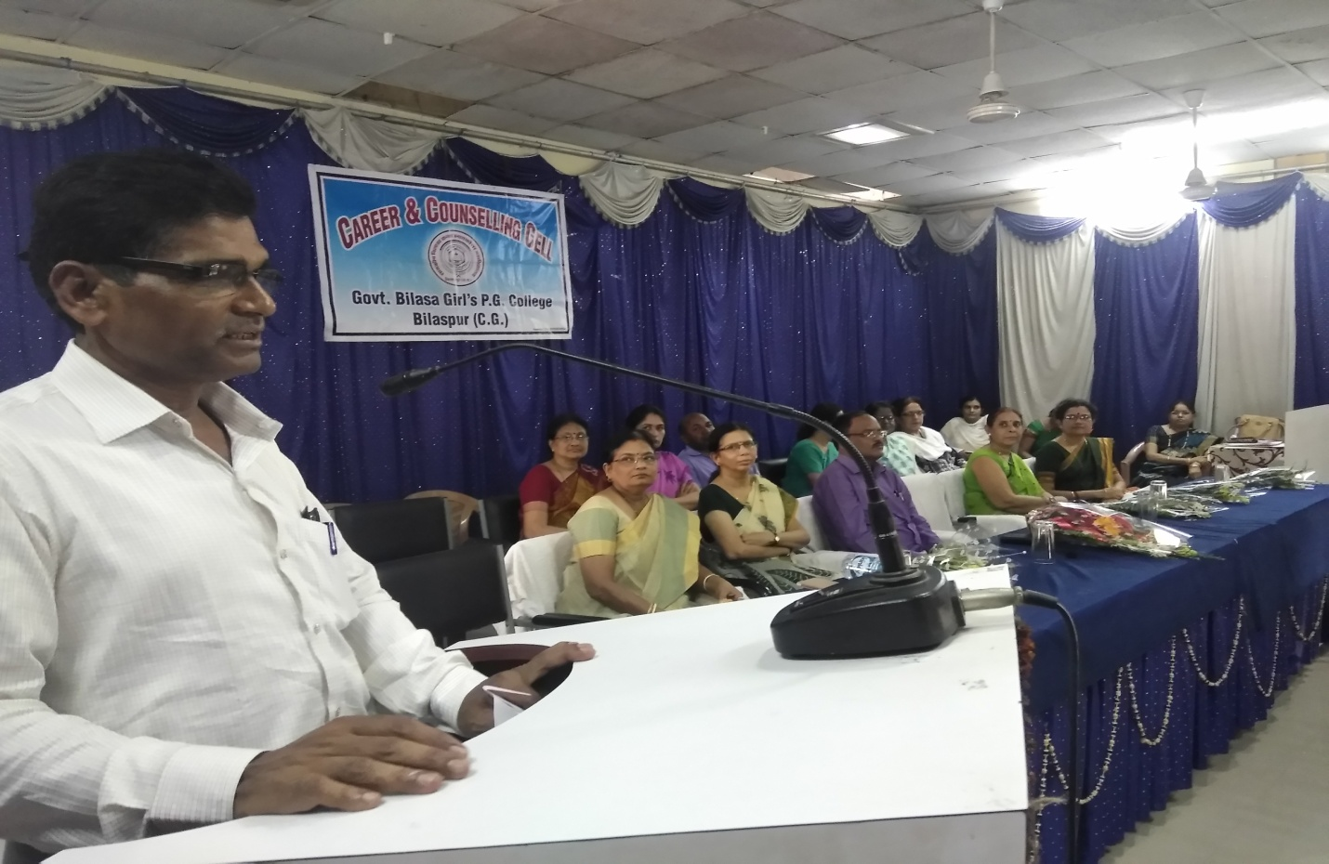
Dr. D. S. Thakur, Convener-Disciplinary Committee & Chief Editor of College Magazine “Abhivyakti”

Dr. Thakur stressed on the fact that this college is known for maintaing discipline in
the college and the students have to strictly follow all the rules and regulations
formed to maintain discipline in the college.

Publication of articles is the most important aspect to spread knowledge
from one corner to another. It not only enriches the faculty members in terms
of knowledge but also provides a gateway to spread their thoughts in the
academic arena. This Cell is also instrumental in bringing out the College
Magazine “Abhivyakti” every year.

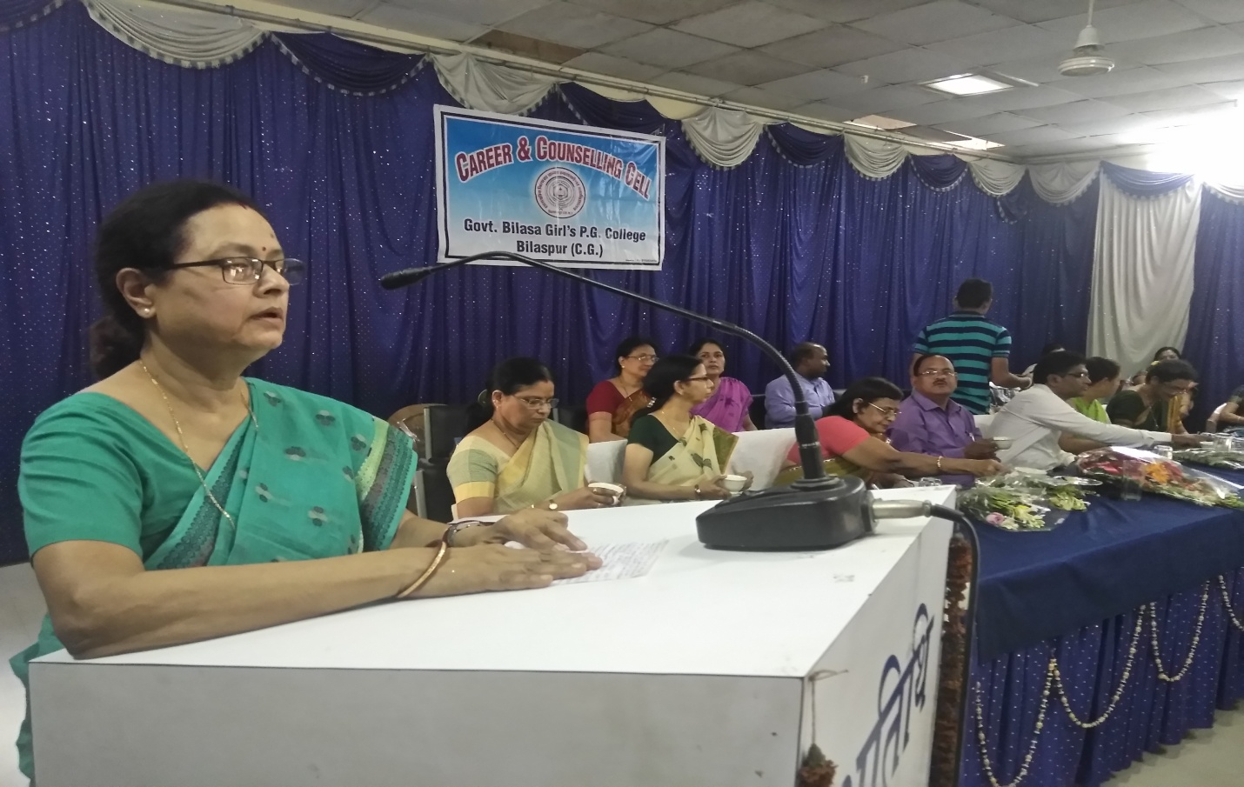
Dr. Madhuri Nanda, Convener-Placement Cell & Add-on Courses

After the completion of their UG or PG courses students need to strive for
their placement and to fulfill the purpose in the college there is a Placement Cell
is functioning. This cell makes the students aware of various career opportunities available in the market.

Any regular student of this college can take admission in the Add-on courses running in the college by various departments. Dr. Nanda has given all the informations to the students of First Semester regarding Add-on courses.

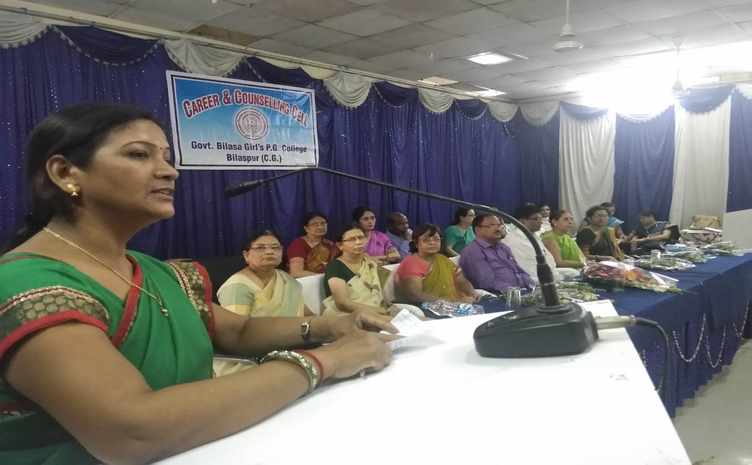
Dr. Manju Madhuri Bajpeyi, Programme Officer-NSS

To provide an opportunity to work for the society is the aim of NSS (National Service Scheme). It is a platform to develop the personality of the students through social services. NSS Unit of the college has the credit of being one of the most creative units of the division. Various camps like Blood Donation Camp, Public Awareness Camp, Clean City, Green City programmes are organized by the Unit from time to time. In the month of July enrollment process takes place. The college has two Units of NSS. Ms. Shaivali Golap is the Programme Officer
for the Second Unit.

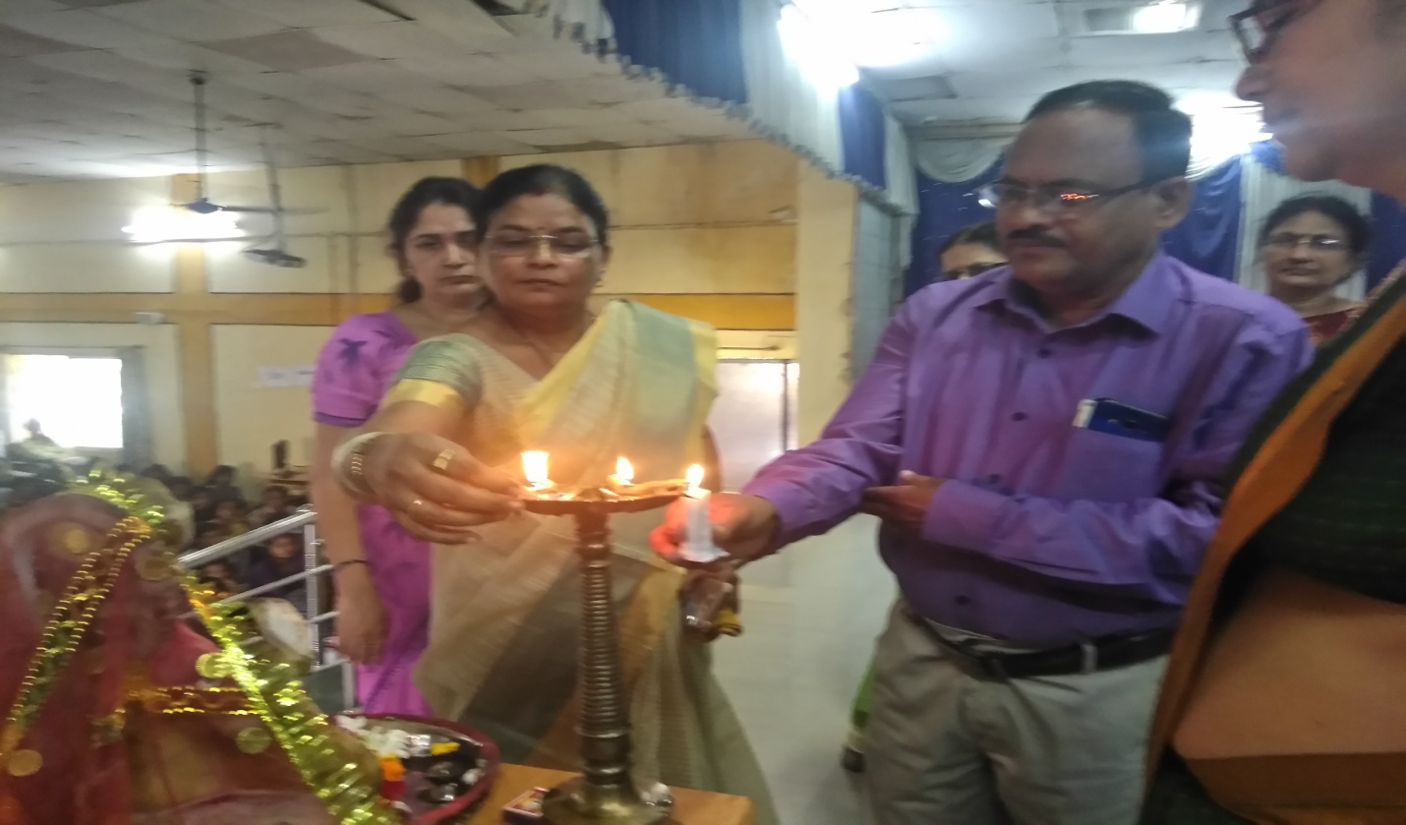
At the very outset of the Induction Programme Honourable Principal Sir along with the Professors lit diyas, offered flowers to goddess Saraswati and perform puja.

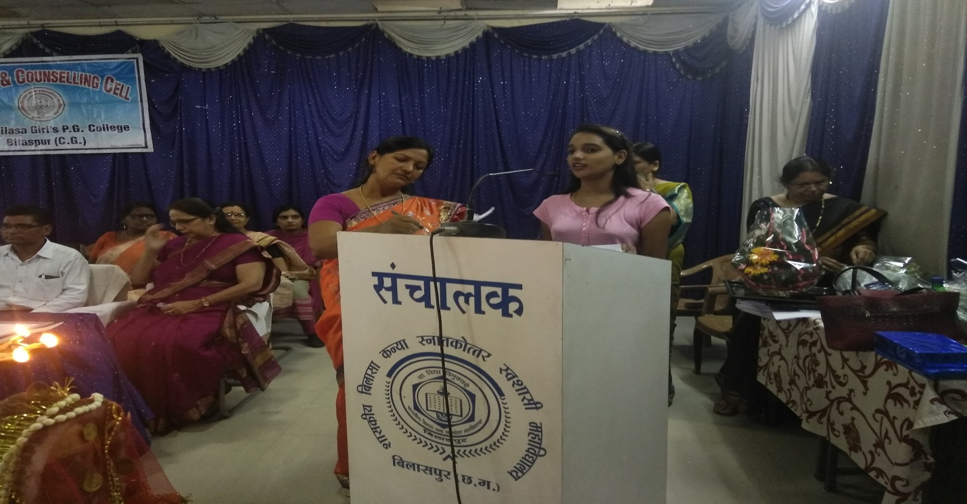
A melodious Saraswati vandana has been rendered by the student of First Semester.

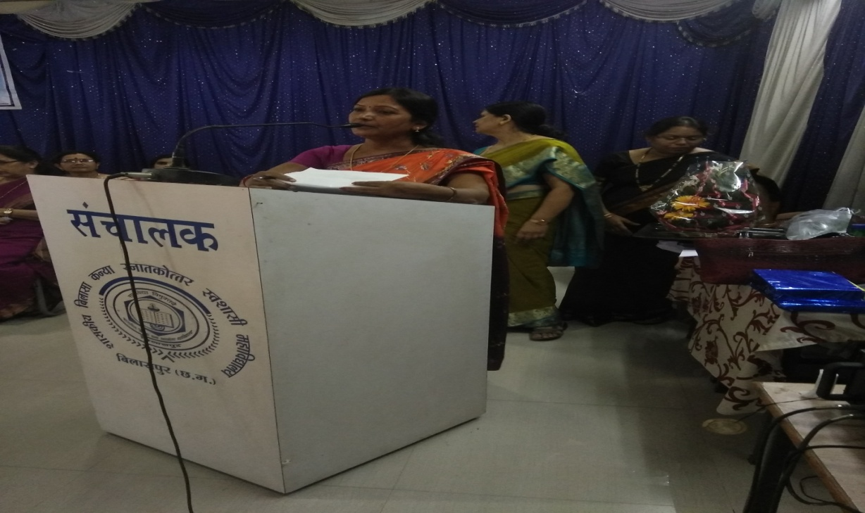
The Induction Programme on 22nd August has been well conducted by Dr. Manju Madhuri Bajpei. The programme was organized for the students of B.A. & B.Com. First Semester.

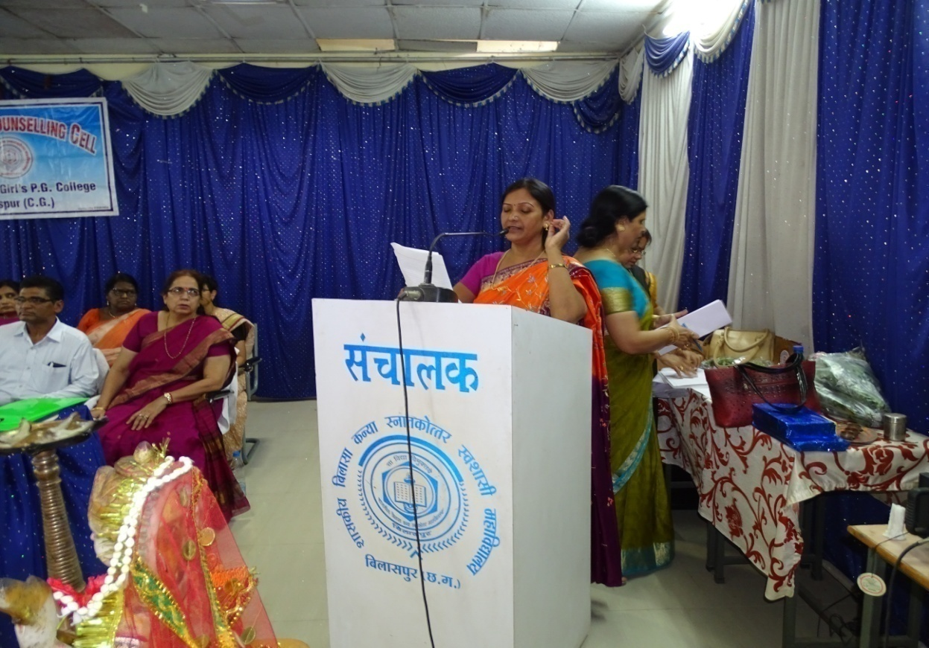

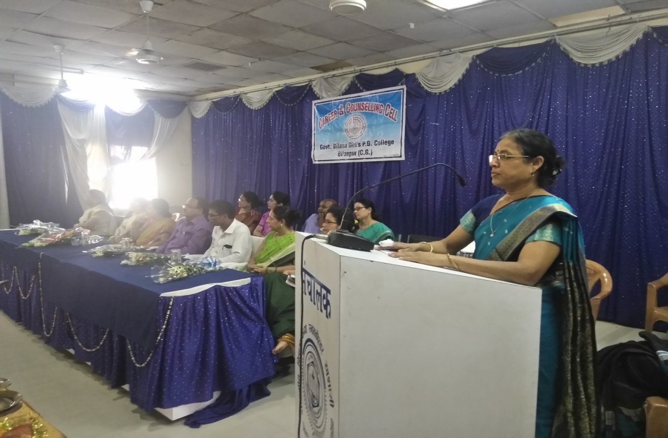
On 23rd August the Iduction Programme was organized for the students of B.Sc./B.C.A./ B.Sc. (Home Science) First Semester. The programme has been well conducted by Dr. Pushpa Bhandari.

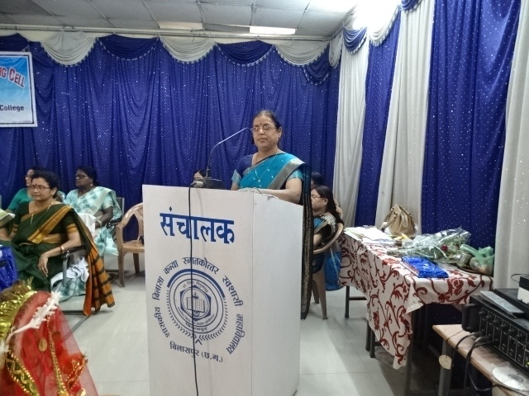

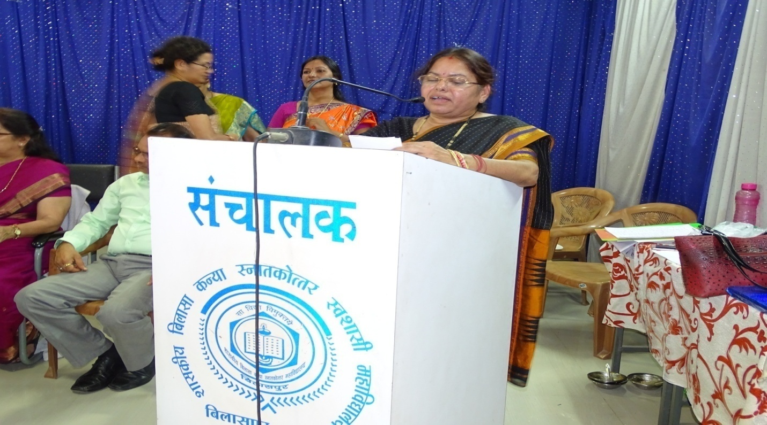
Vote of thanks has been rendered by Dr. Sangeeta Shukla.

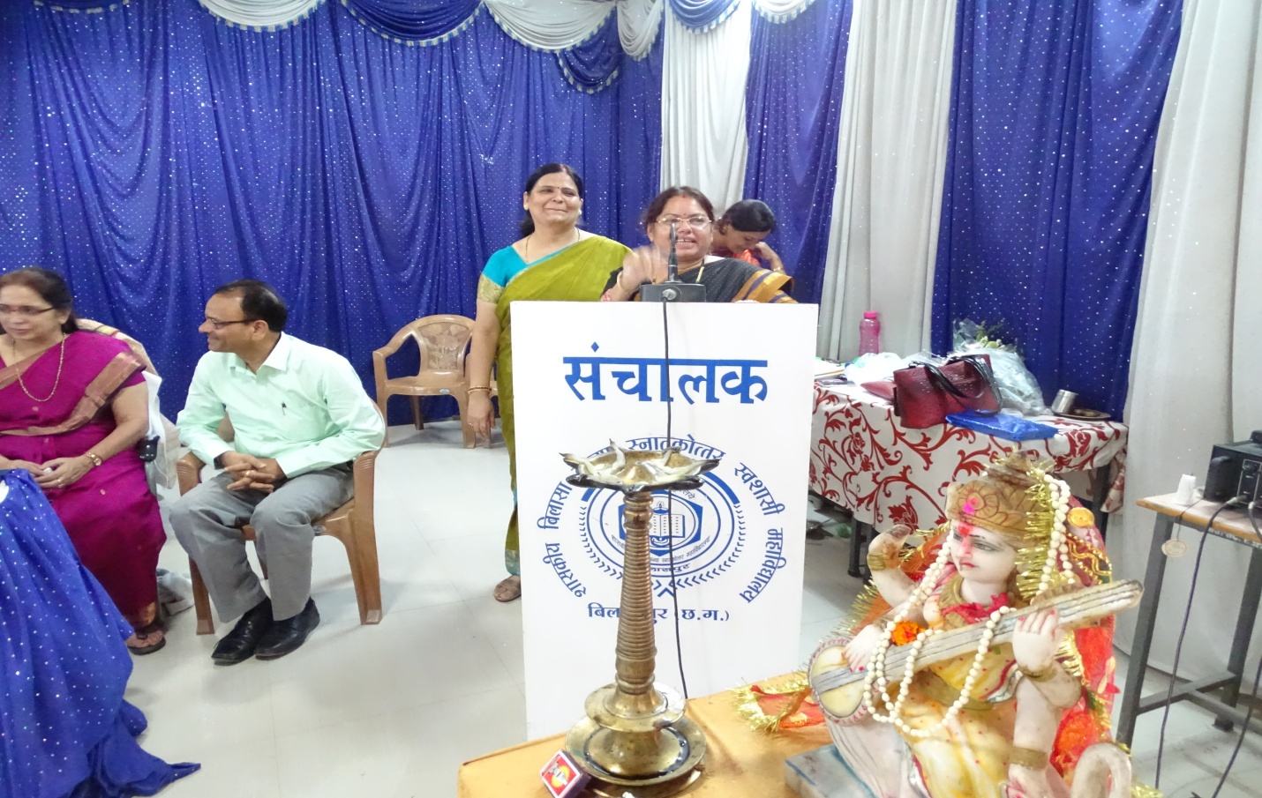

National Anthem “Jan Gan Man……” is being rendered.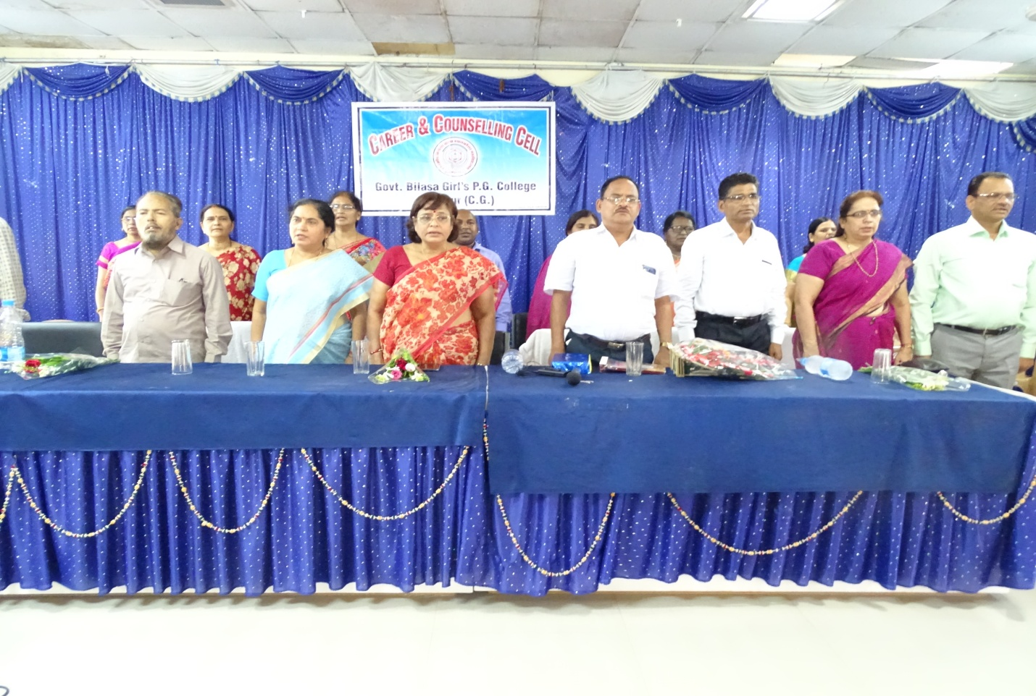
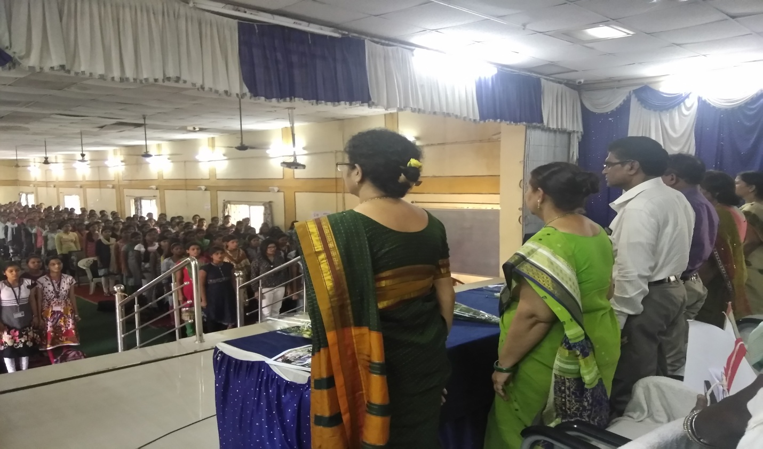

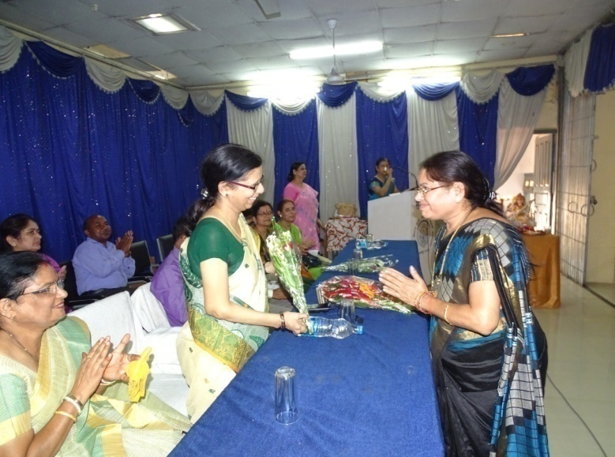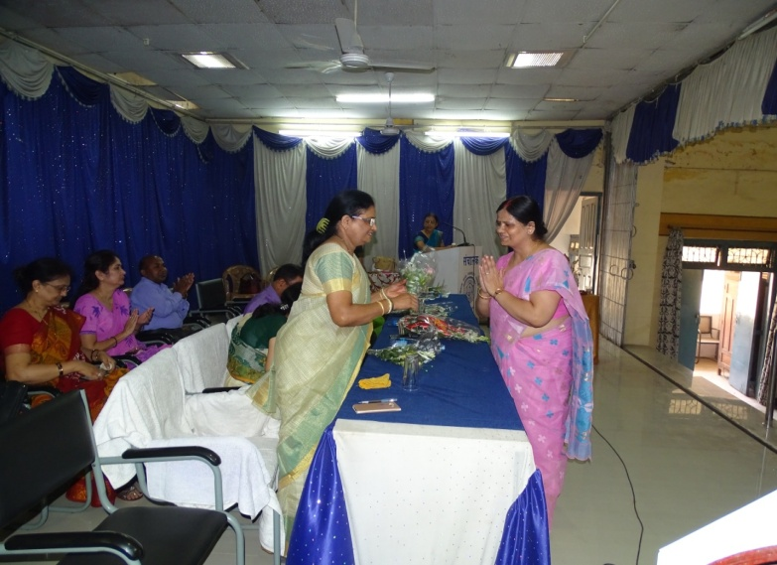
Dr. Sangeeta Shukla welcoming Dr. Rahalker Dr. Archana is being welcomed by Dr. Archana

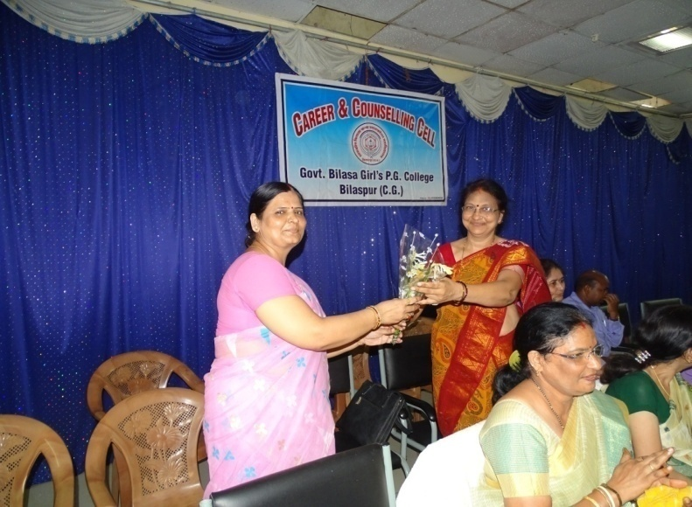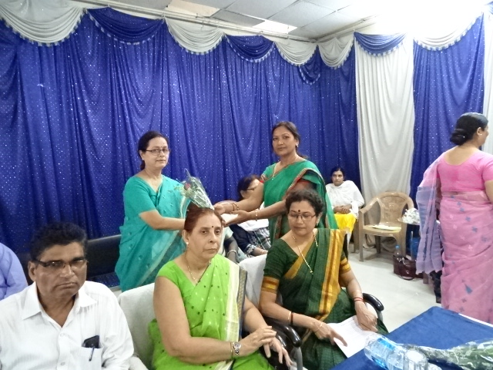
Dr. Singh welcoming Dr. Premlata Verma Dr. Manju Bajpei welcomes Dr. Nanda

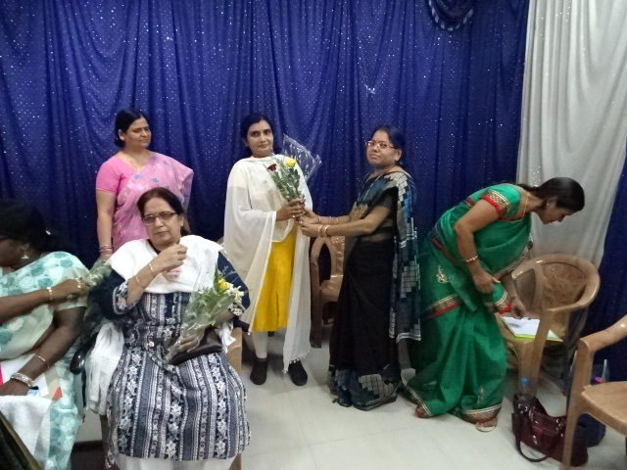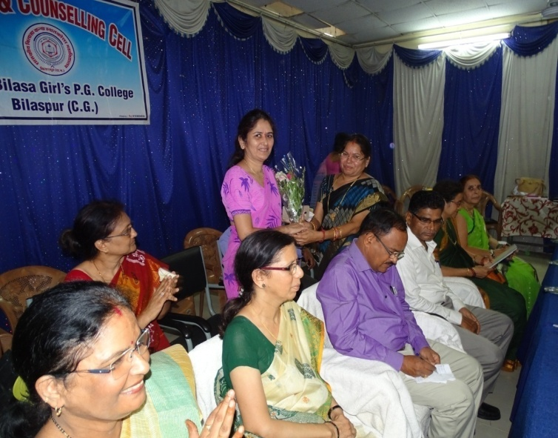
Ms. Shaivali Golap welcomed by Dr. Shukla Dr. Shukla welcomes Ms. Sushma Ghai

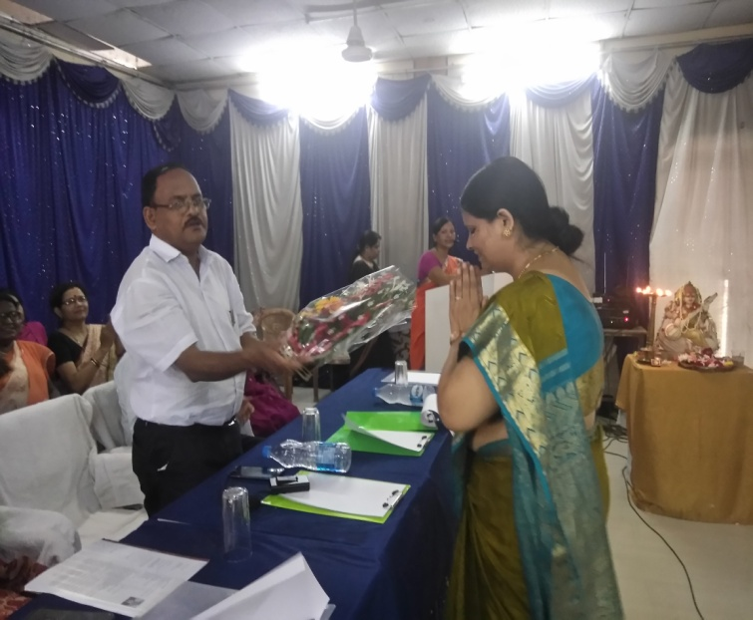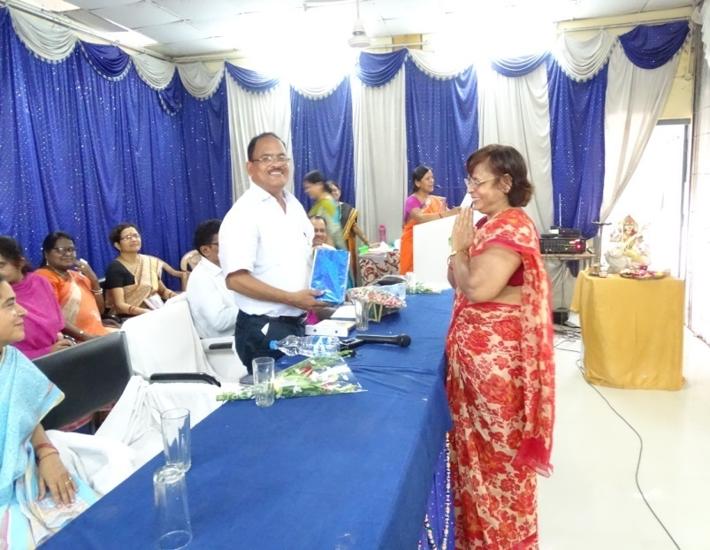
Principal Sir welcomed by Dr. Singh, Convener Dr. Vajpai welcoming Principal Sir

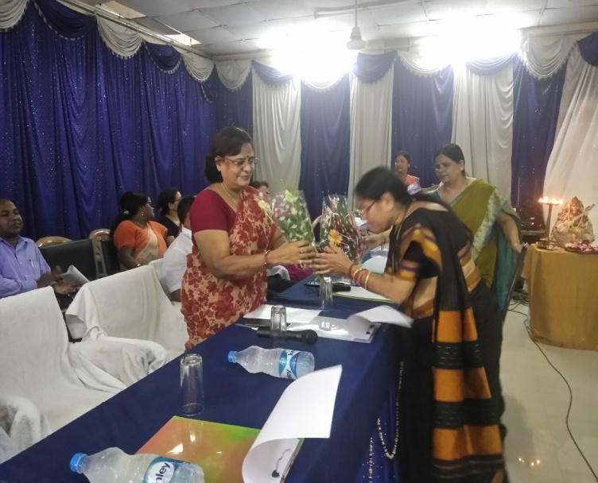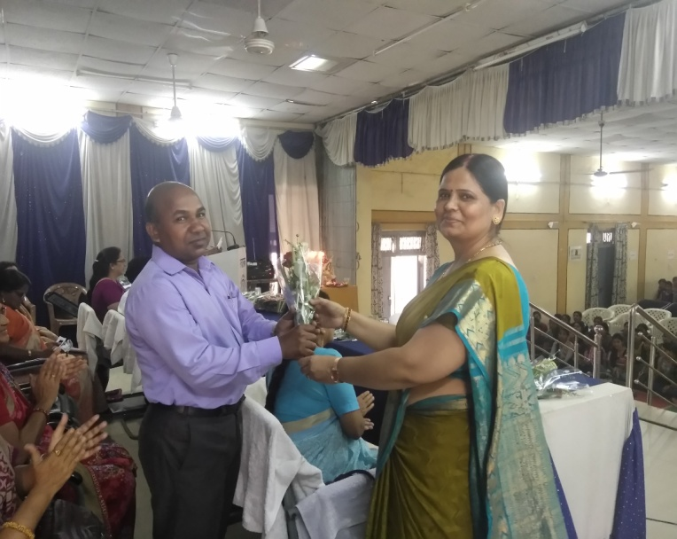
Dr. Sangeeta Shukla welcomes Dr. Kiran Vajpai Dr. Singh welcoming Dr. Choudhary

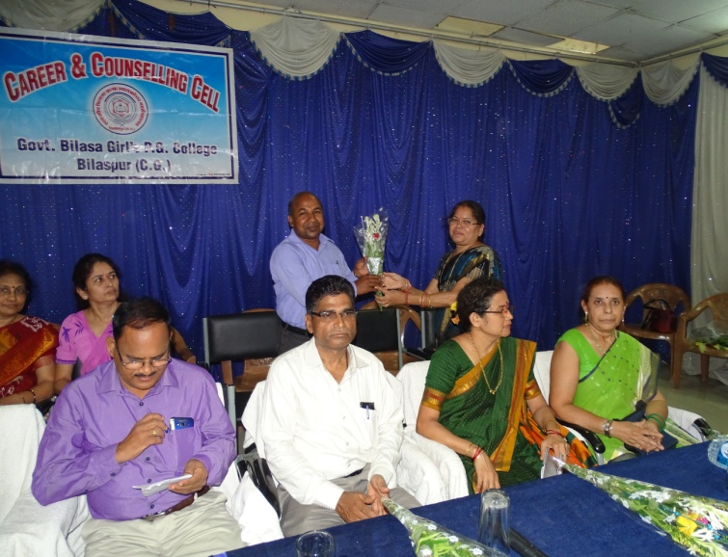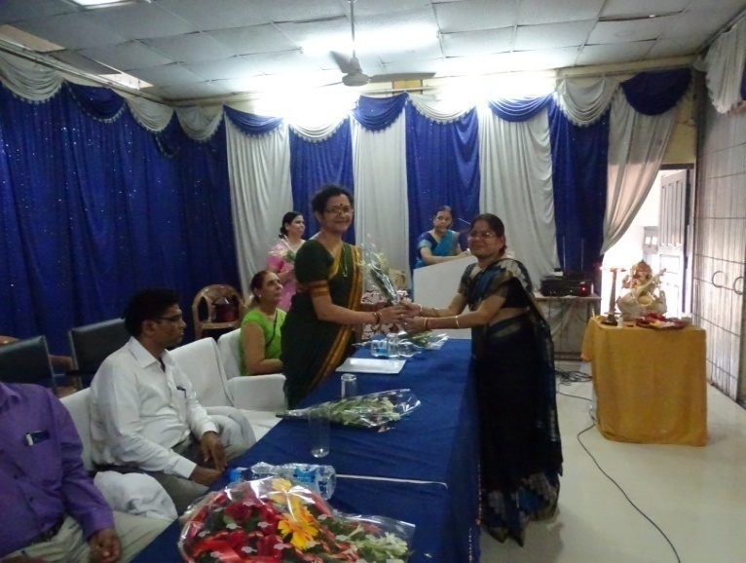
Dr. Shukla welcoming Dr. Choudhary Dr. Dabhadkar is welcomed by Dr. Shukla

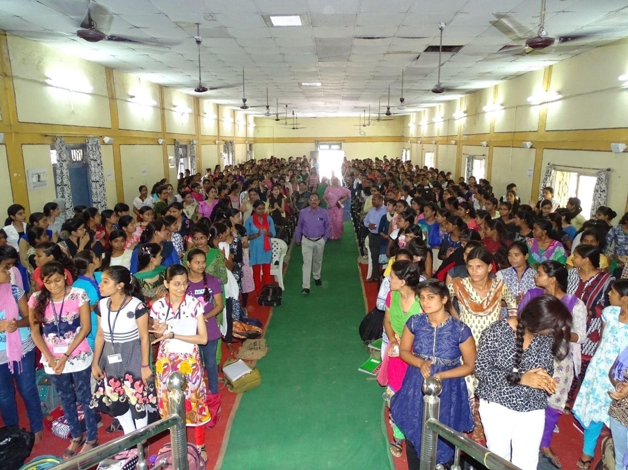
First Semester’s students welcoming Principal Sir with a big round of applause

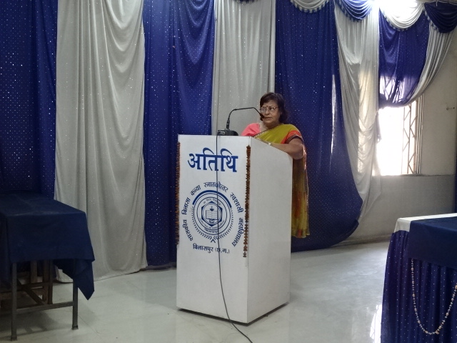
Dr. Kiran Vajpai, Vice-Principal addressing the students of First Semester

Dr. Kiran Vajpai being the ex-principal of this college informed students about various programmes being run in the college and also made them aware of the Rules and Regulations of the college that must strictly be followed by the students especially regarding discipline and anti-ragging.

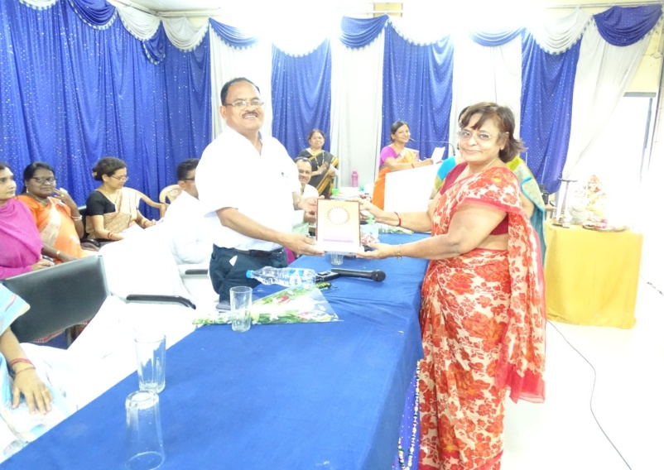 Memento is being presented to the Princiipal Sir by Dr. Kiran Vajpai

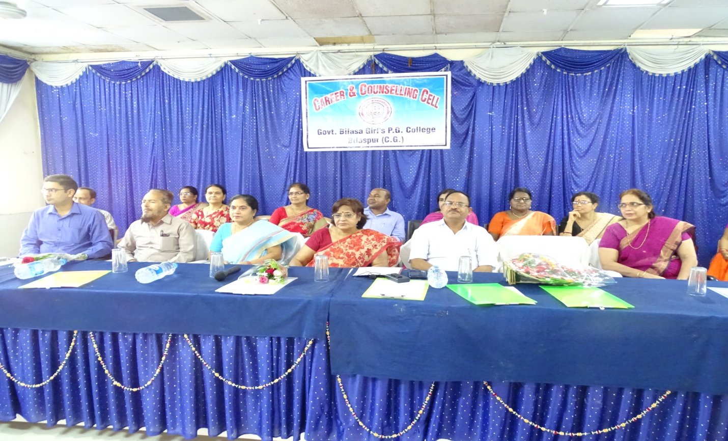
Principal Dr. S.L.Nirala and Officers Staff of the college on the dias.

Career & Counseling Cell: A Report
2017-18

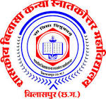

Dr. S. L. Nirala Dr. Archana Singh (Convener)
PRINCIPAL Dr. Pushpa Bhandari (Member)
Dr. Sangeeta Shukla (Member)
Dr. Manju Madhuri Bajpei (Member)

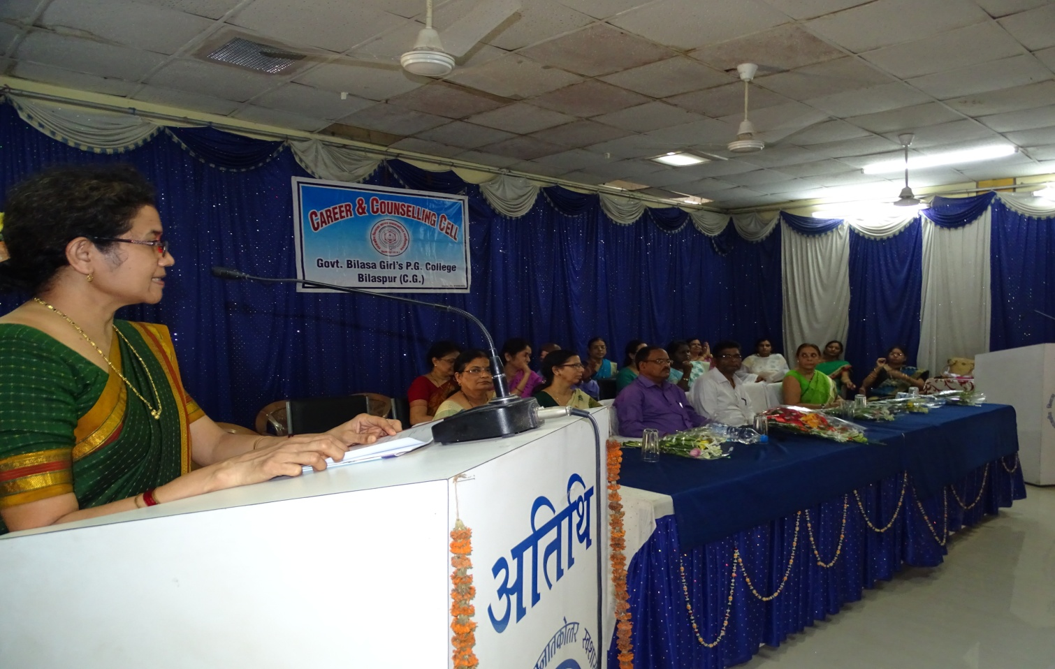
Dr. Kaveri Dabhadkar, Incharge-Autonomy Affairs & Nodal Centre addressing to the students of First Semester

Dr. Dabhadkar has informed the students about the Nodal Centre and Internet facility in the college. The college has a well-equipped Computer Nodal Center and Internet facility. Computer training facility has been provided to the teachers and office staff of the college. For easy Internet Connectivity free Wi-Fi facility is available in the campus of the college for all the staff and students, with a speed of 10mbps.

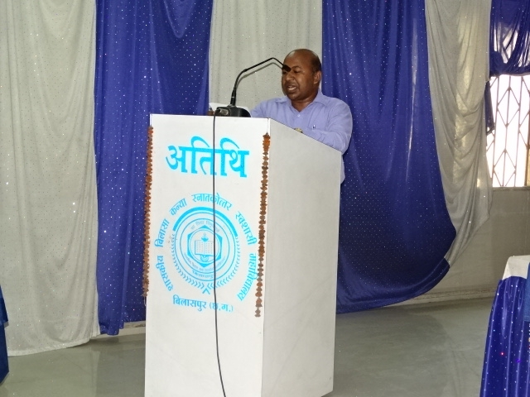
Mr. B.R.Choudhary, Librarian informing about the infra-structure of the library.

The college has a well-furnished library having more than 53000 books and subscribing to various journals. The library stocks many old and prestigious books. Many of the books have been donated by various people on various subjects. A special section is devoted to the Gandhian Literature.

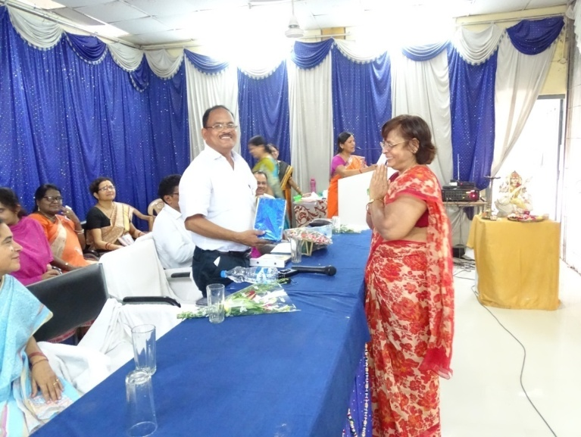
Dr. S.L.Nirala, Principal is being welcomed by Dr. Kiran vajpai, Vice-Principal

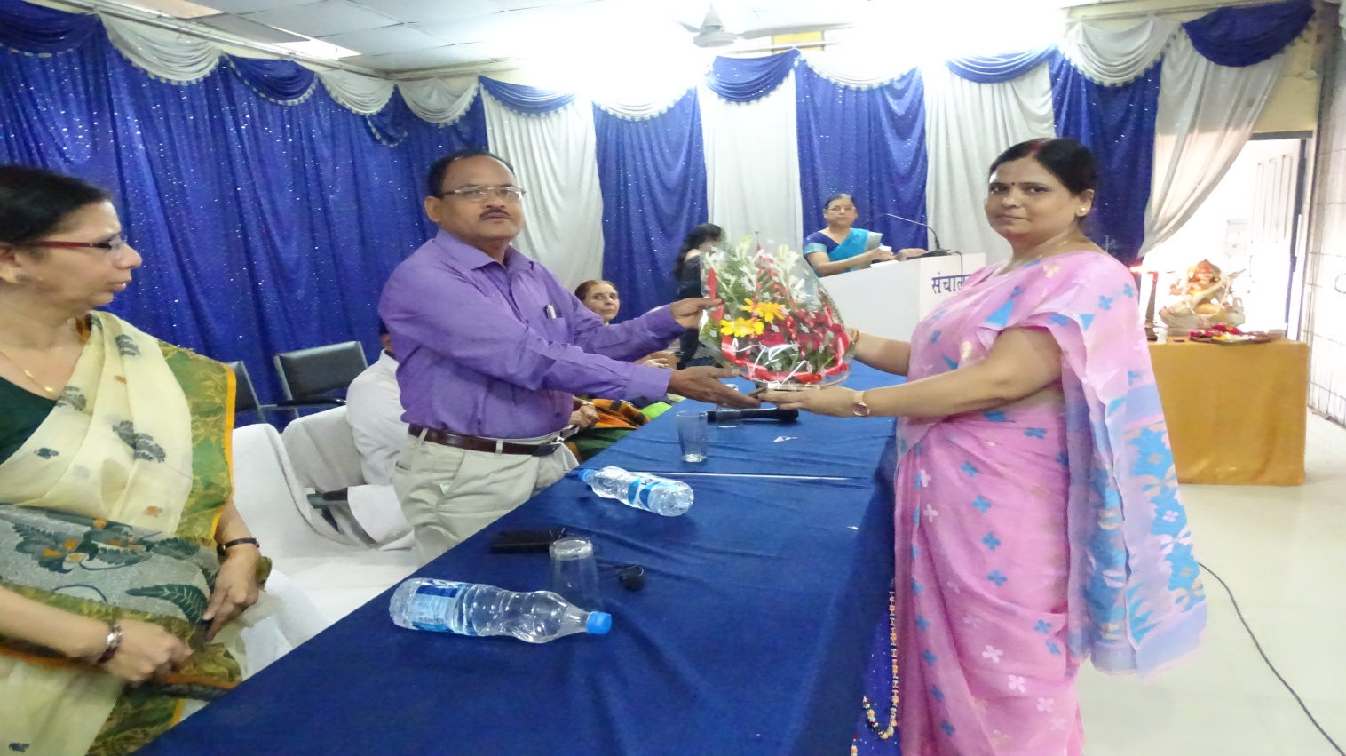
Dr. S.L.Nirala, Principal is being welcomed by Dr. Archana Singh, Convener

Under the programme of MYSY (Mukhyamantri Yuva Swavalamban Yojna) students have been informed and trained about the interviews and Group Discussion. Dated: 11th November, 2017

Under the programme of MYSY (Mukhyamantri Yuva Swavalamban Yojna) many students have been selected for the job. In order to face Interviews they have to go for the Group Discussion. This responsibility has been taken up by the Career & counselling Cell. On 11th November, 2017 Convener of the cell Dr. Archana Singh has made them aware of Group Discussion and a mock Group-Discussion has also been organized for them. Dr. S.L.Nirala, Principal and MYSY Nodal Officer Dr. Aradhana Sharma also shared their views on this occasion.

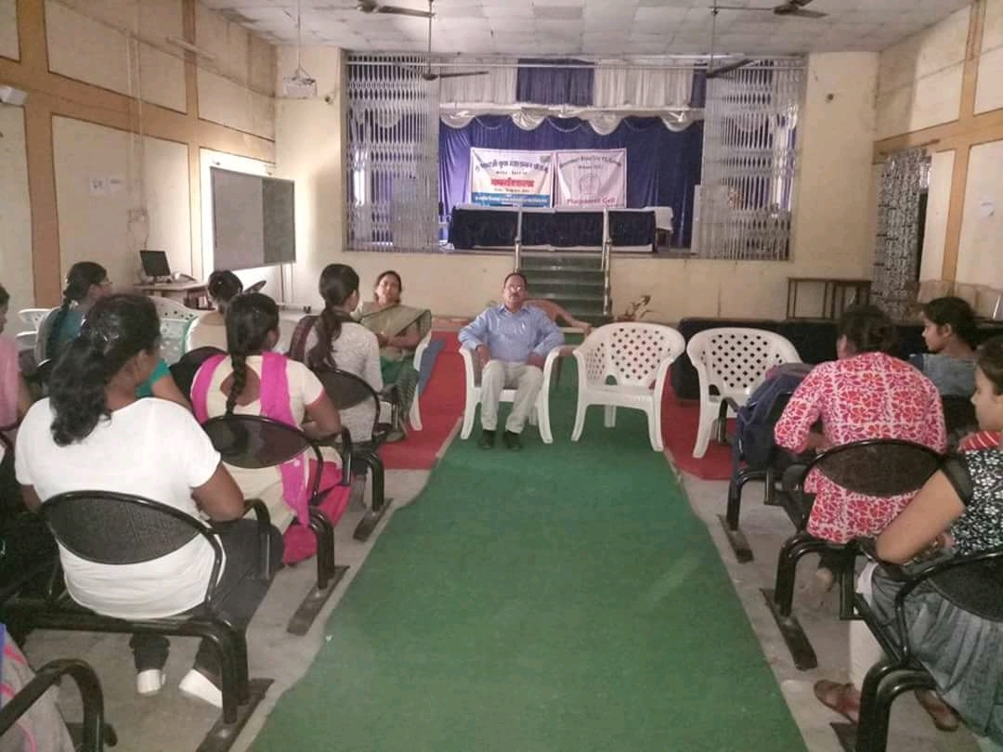
Principal Dr. S.L.Nirala and MYSY, Nodal Officer Dr. Aradhana Sharma

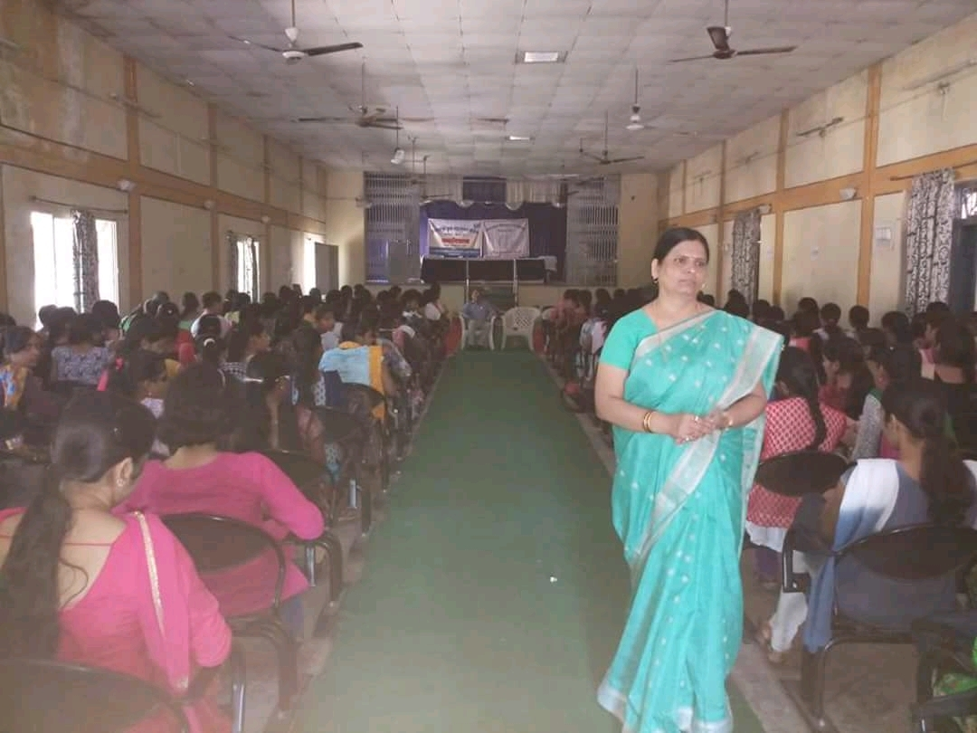
Main Trainer Dr. Archana Singh, Convener, Career & Counselling Cell

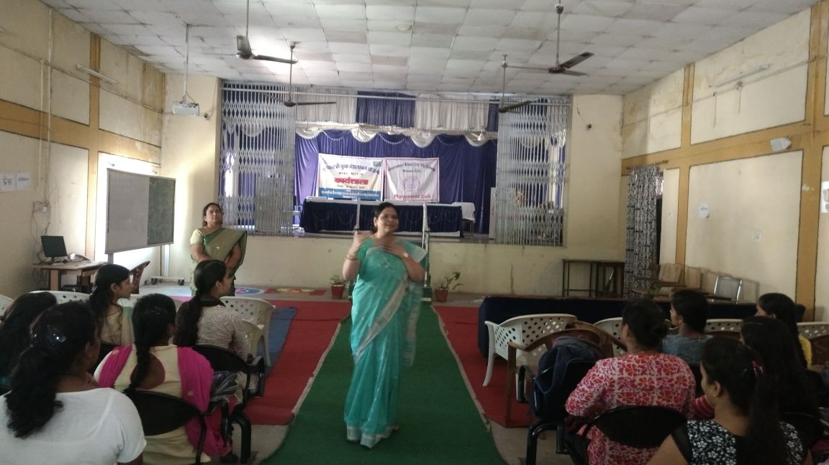

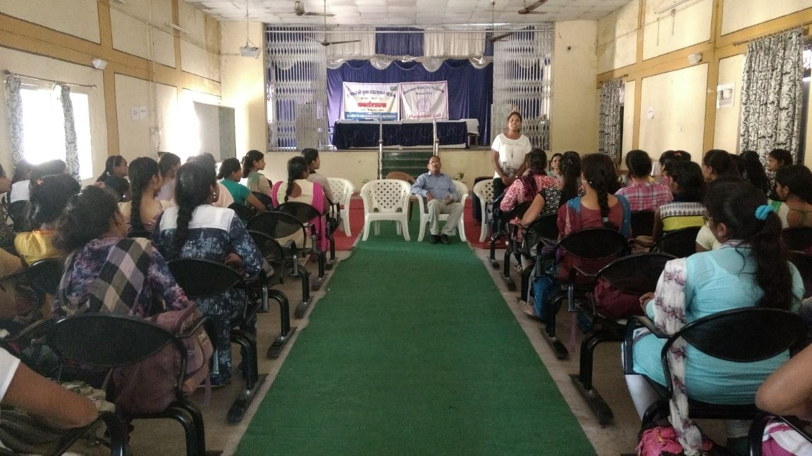
Mock Interview Session

In the continuation, on 5th September, 2017 Career Guidance Seminar has been organized by the Career Launcher. Mr. Jayesh Gumber has guided the girls that the greatest barrier to success is the fear to failure. The aspirants must first of all to overcome this fear.

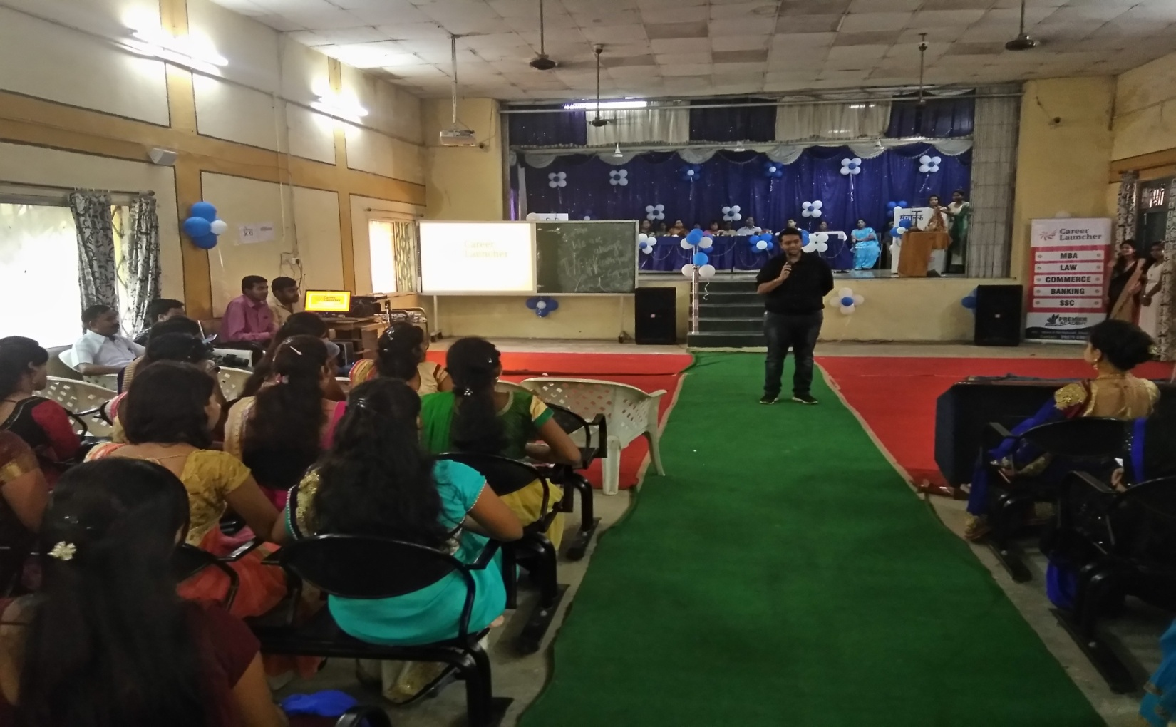
Mr. jayesh Gumber addressing the students

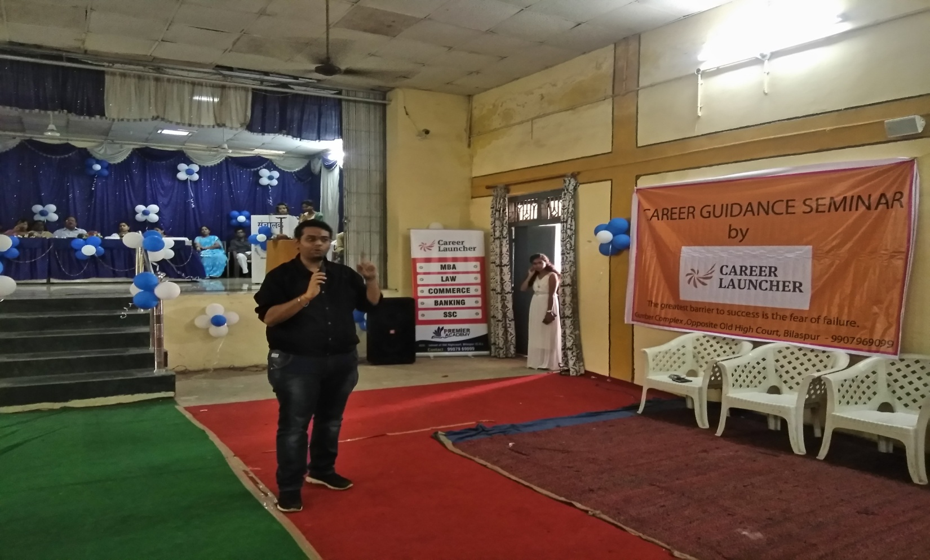

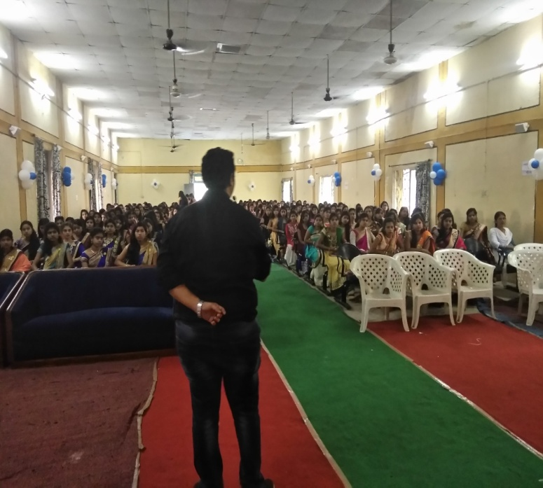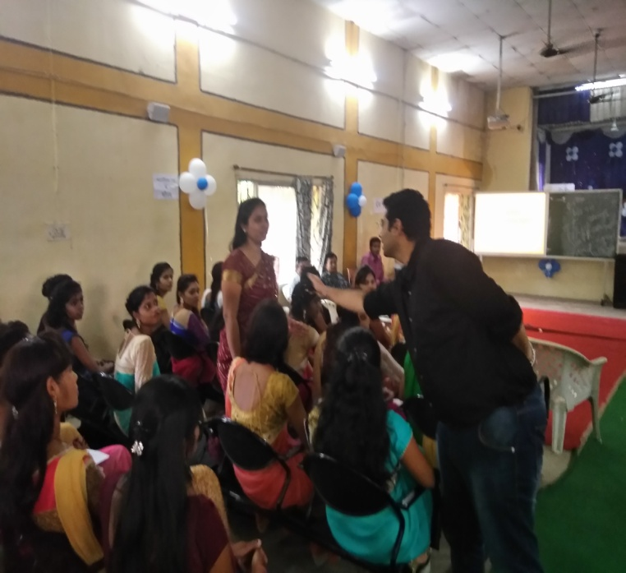

On 23rd August, 2017 Mr. Narendra Singh from NUSSD, National University of Students’ Skill Development Programme has introduced the students about their Skill Development Programme and the scope of its placement. TISS (Tata Institute of Social Sciences) has taken up the challenge to demonstrate models on skilling people with varying educational qualifications. He also talked about its collaboration with the TISS.
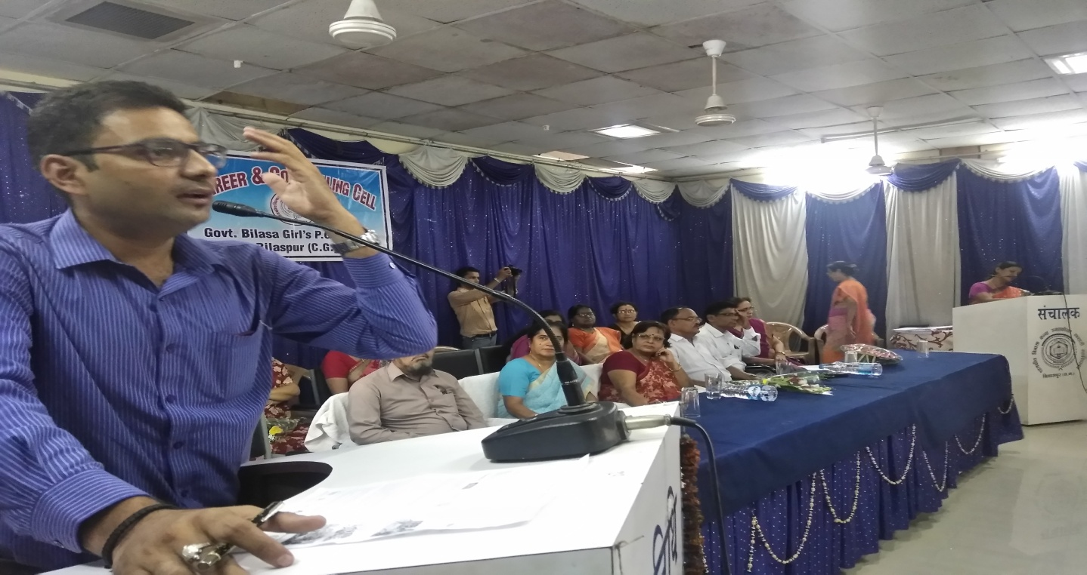
Mr. Narendra Singh from NUSSD, National University of Students’ Skill Development Programme addressing the students.

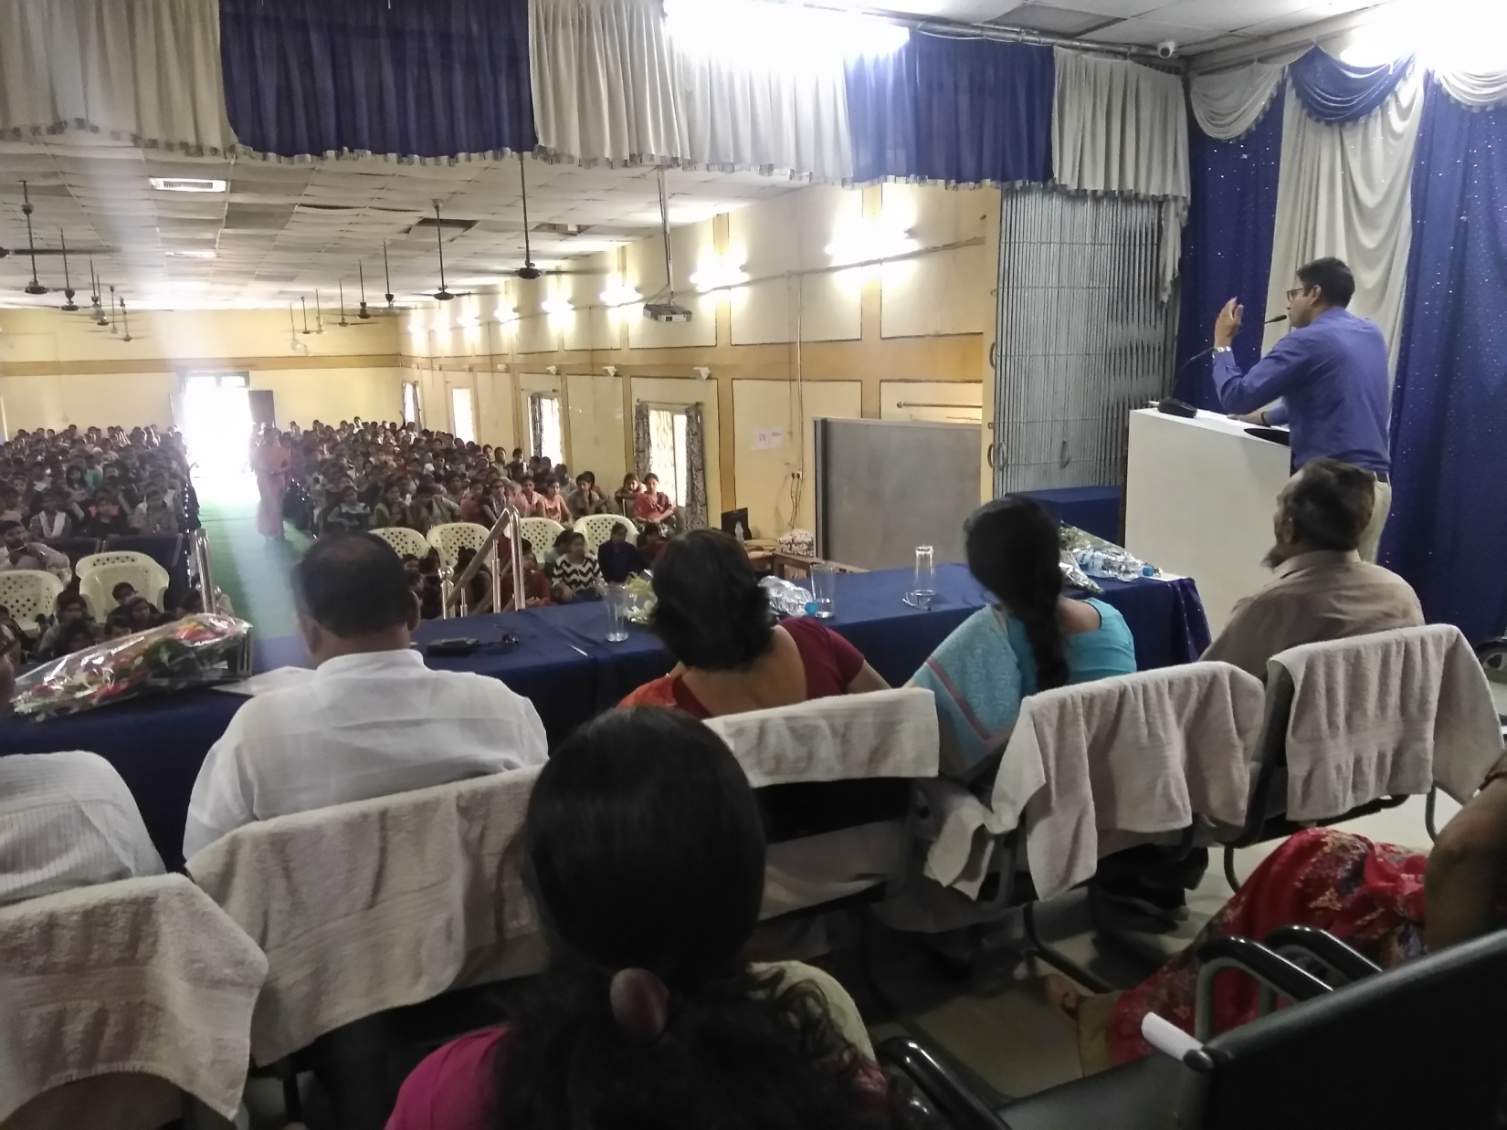
Students gathering at the Programme

On 27th of March, Ms. Ayesha Shrivastava from NIBF (National Institute of Banking and Finance) has guided the girls of this college to try in the field of banking and finance. NIBF is a venture with a vision to create a hub of excellence in the field of Banking, Financial Services and Insurance Education in order to fulfill the industry, business requirements and acknowledging the need of the times. In the college, students especially Commerce students have taken keen interest in the programme and asked various questions regarding the advancement of their career.

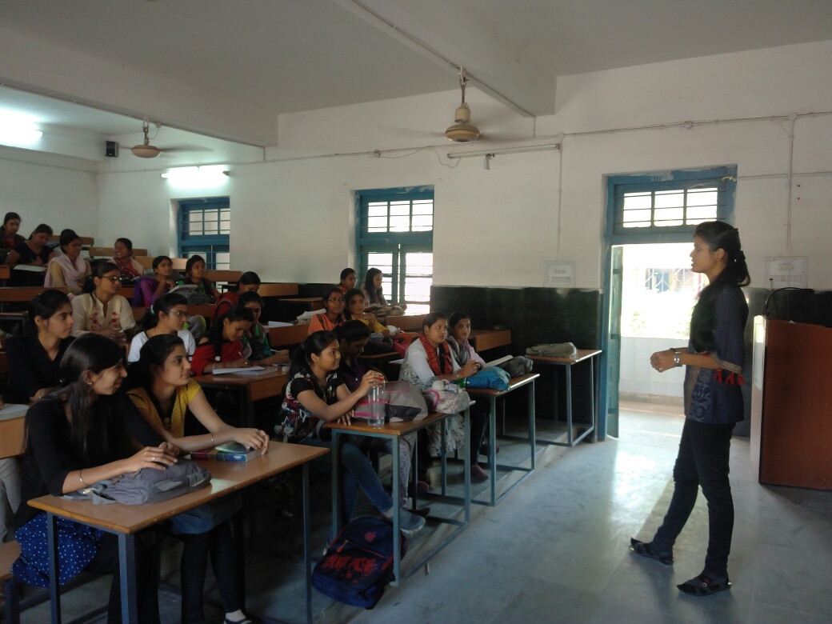
Ms. Ayesha Shrivastava from NIBF addressing the Commerce students

A torch bearer is a person who shows the path of success to others and one who himself or herself is successful in the life and achieved the target of his or her life can become the Torch Bearer in its true sense. A programme has been organised on 4th April, 2018 by the Career & Counselling Cell to invite the officials from various fields, selected by the Public Service Commission of Chhattisgarh to share their experiences and their methods pf preparation with the students and what type of obstacles they had to face while preparing for these competitive examinations. This programme caters to the need of aspirants who concerned for their career and future. Invities were Ms. Jaya Patel, Project Officer, Balodabazar, Ms. Sagar Kumar Raj, CMO, Kota, Ms. Deepti Patel, Project Officer, Takhatpur, Mr. Kashav Patel, Nayab Tehsildar, Bemetara and Ms. Shweta Yadav, Nayab Tehsildar, Bilaspur.

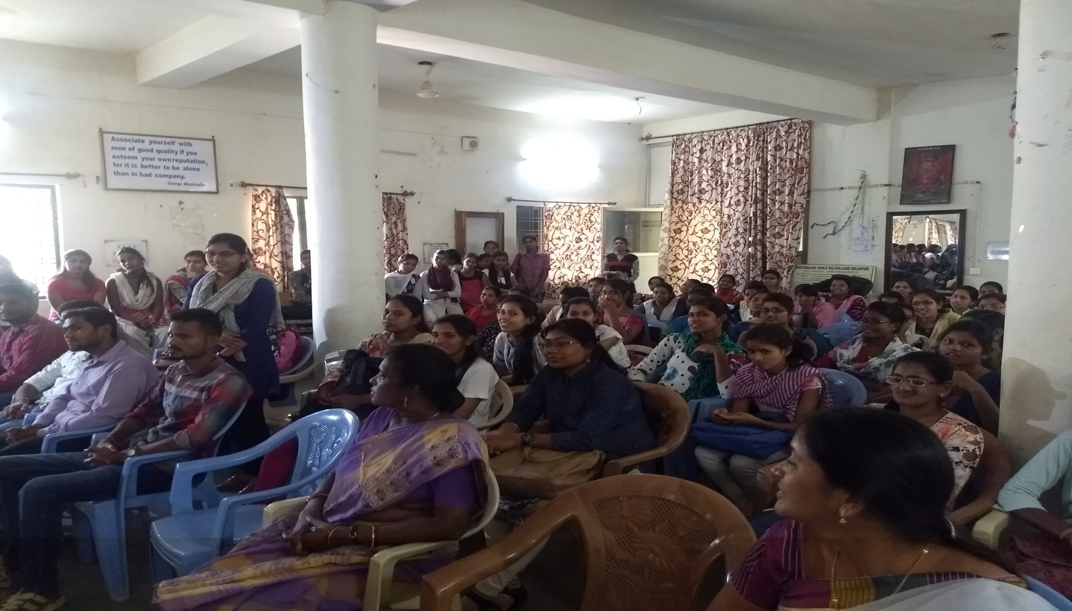
Students gathering at the programme

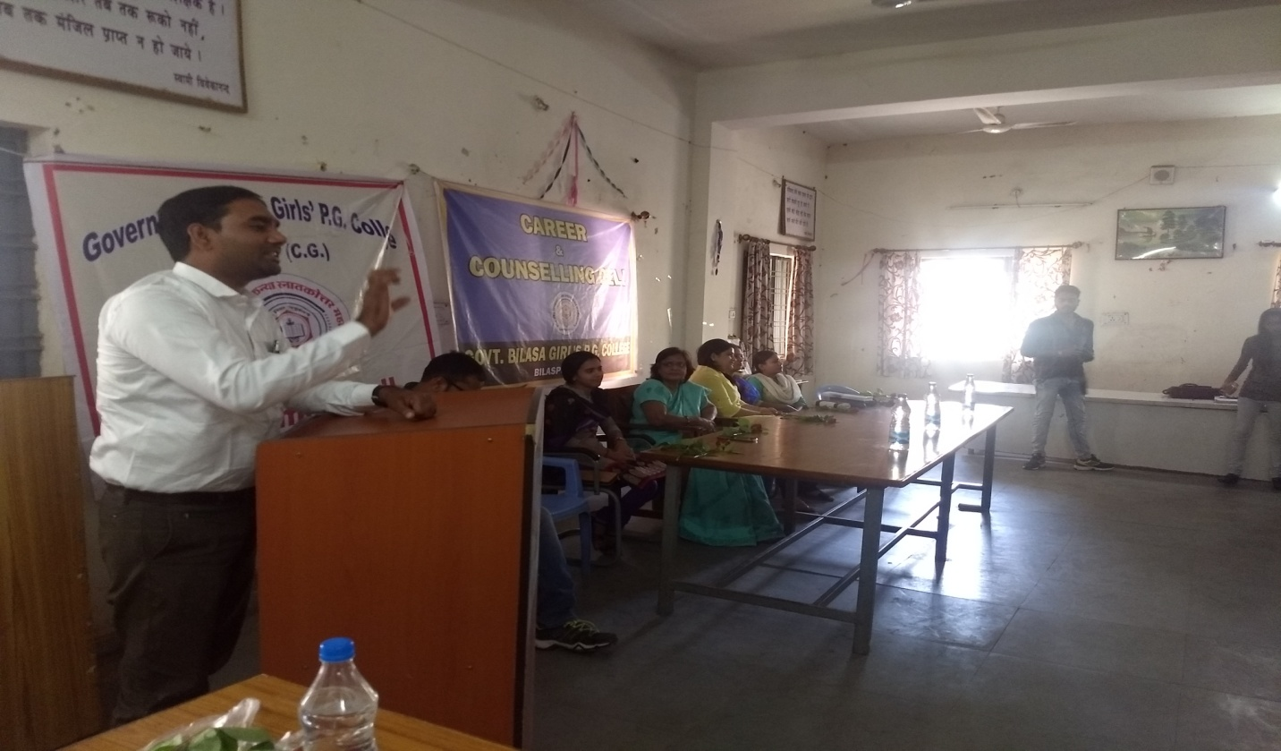
Mr. Kashav Patel, Nayab Tehsildar, Bemetara addressing the students

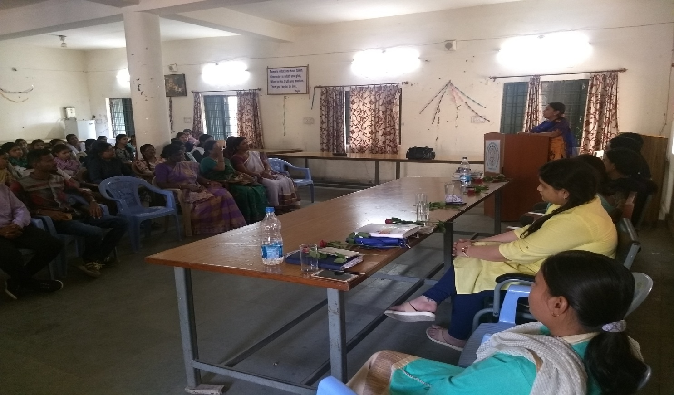
Ms. Jyotsana Choudhary, Project Officer, Balodabazar talking about preparation for PSC

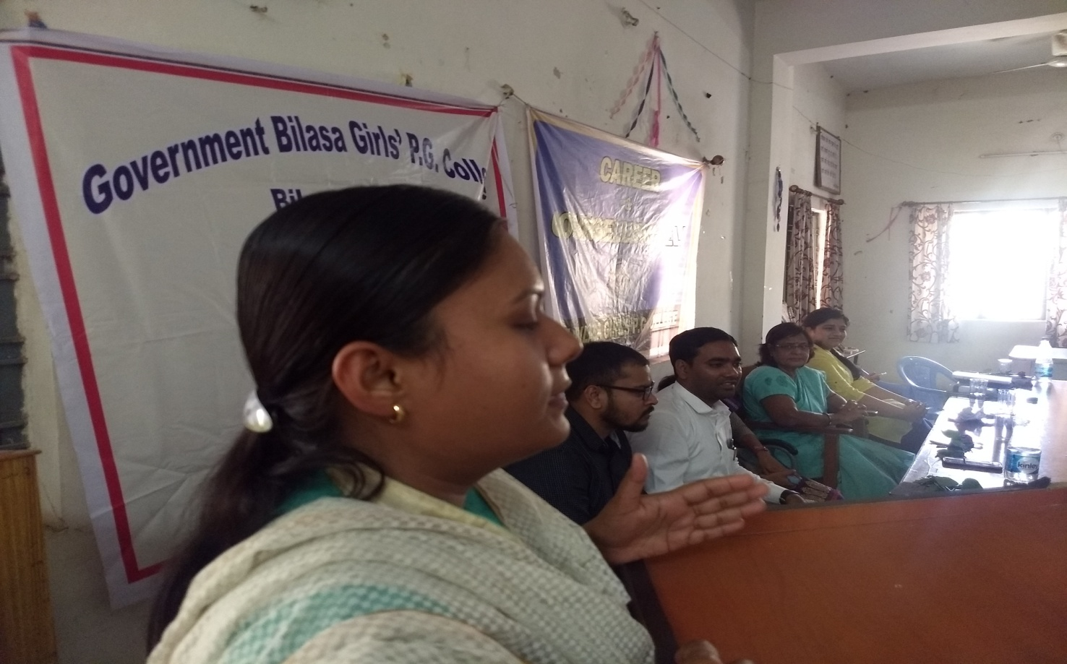
Ms. Jaya Patel, Project Officer, Balodabazar

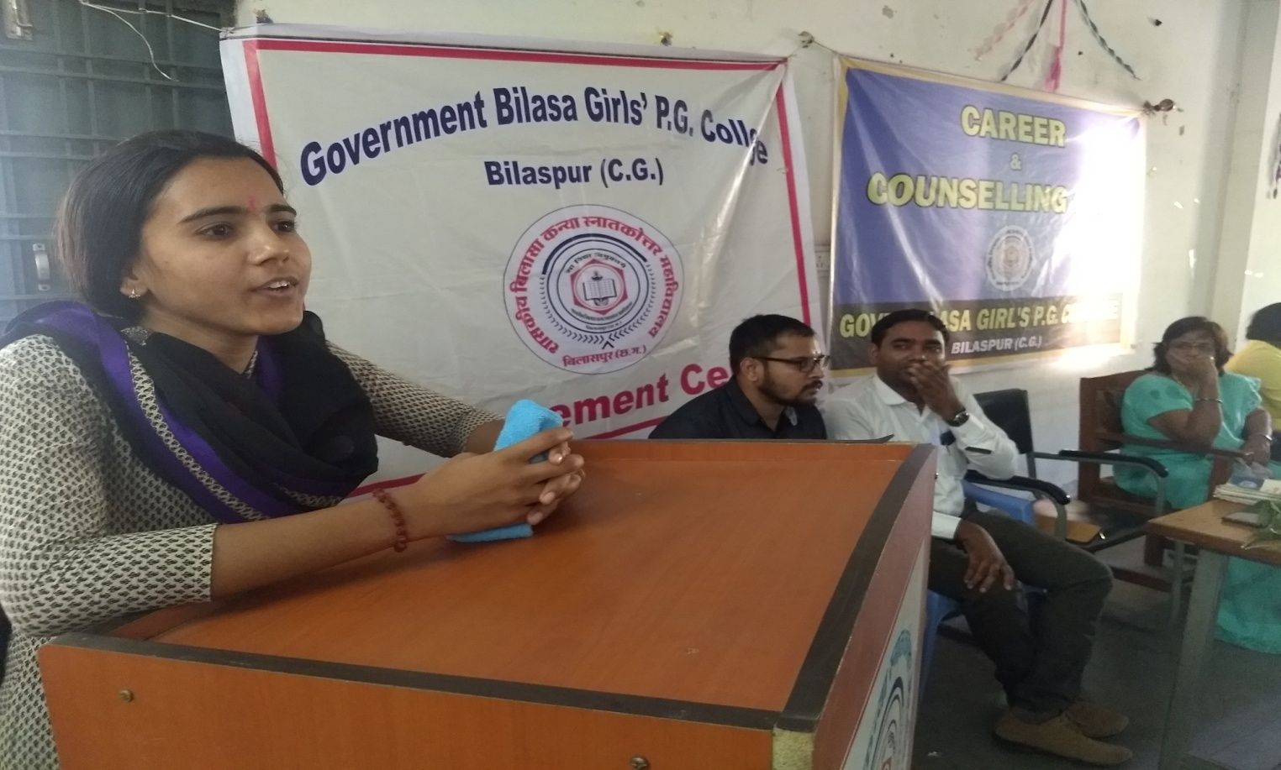
Ms. Deepti Patel, Project Officer, Takhatpur

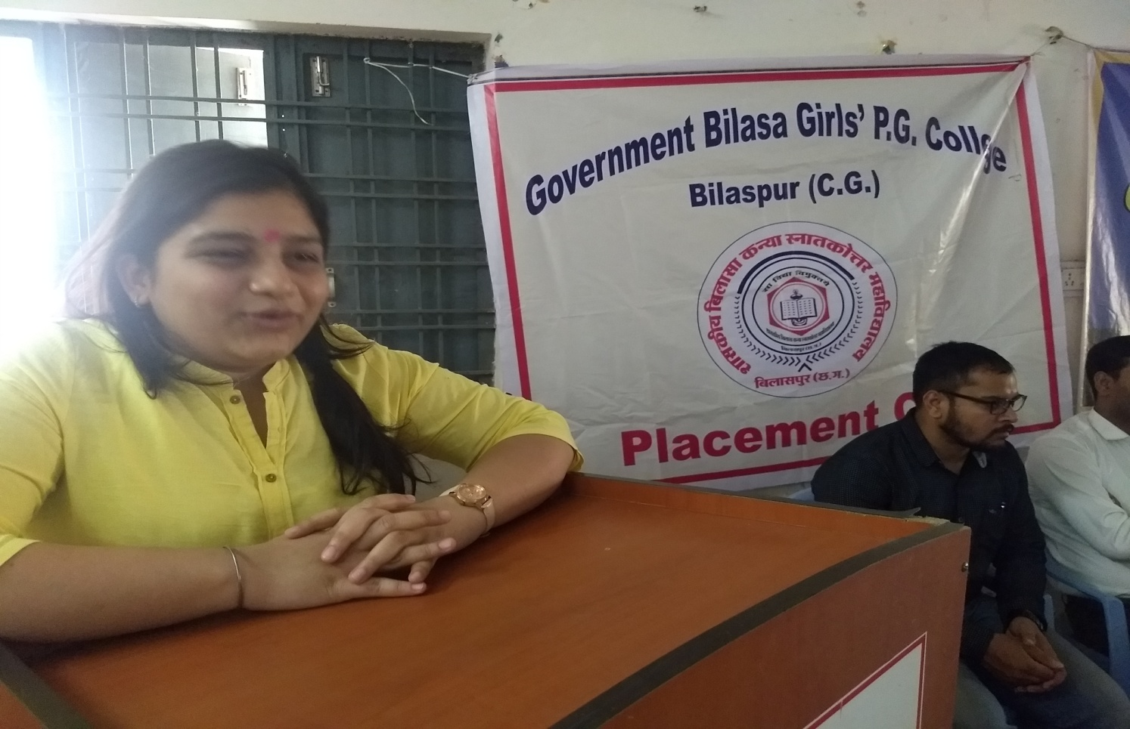
Ms. Shweta Yadav, Nayab Tehsildar, Bilaspur

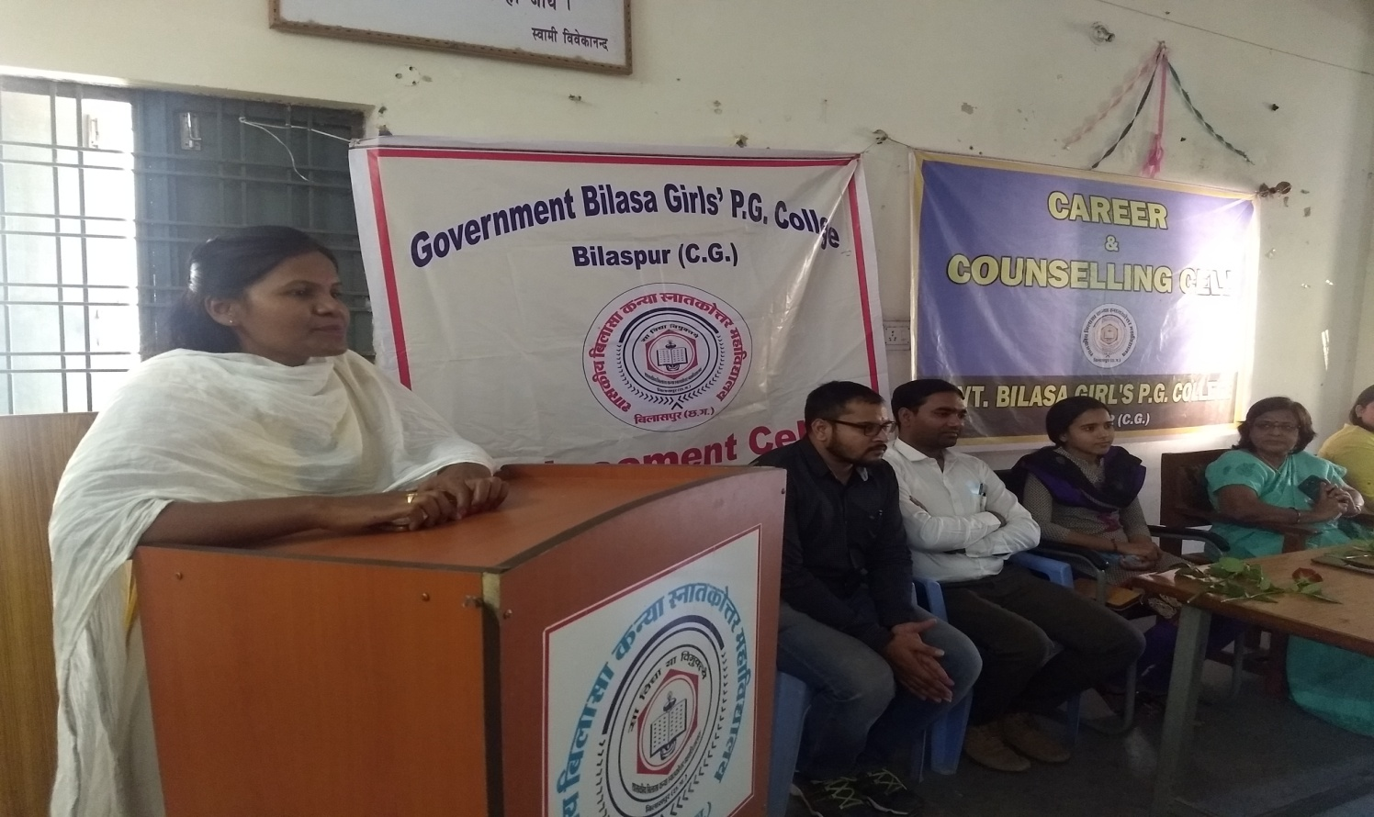
Ms. Sagar Kumari Raj, C.M.O. Kota

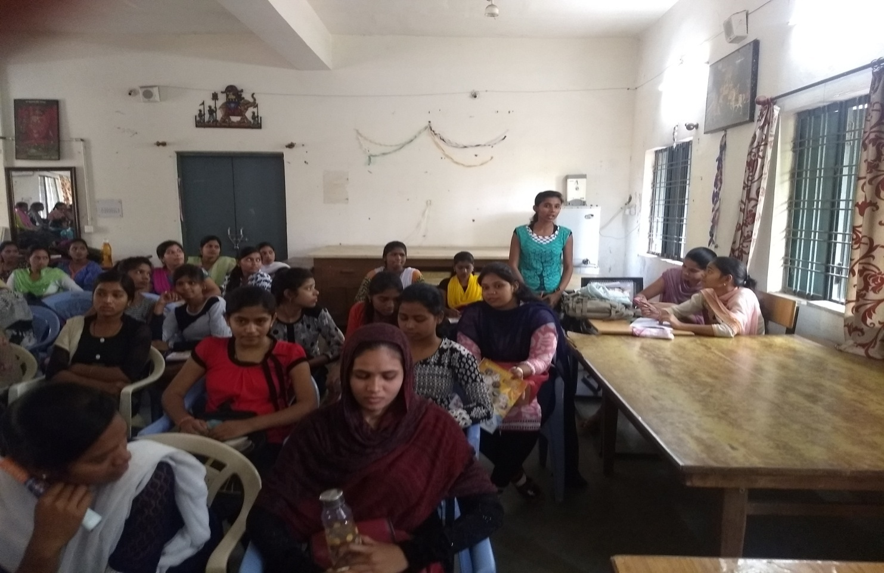
Students satisfying their queries by asking questions regarding preparation for PSC

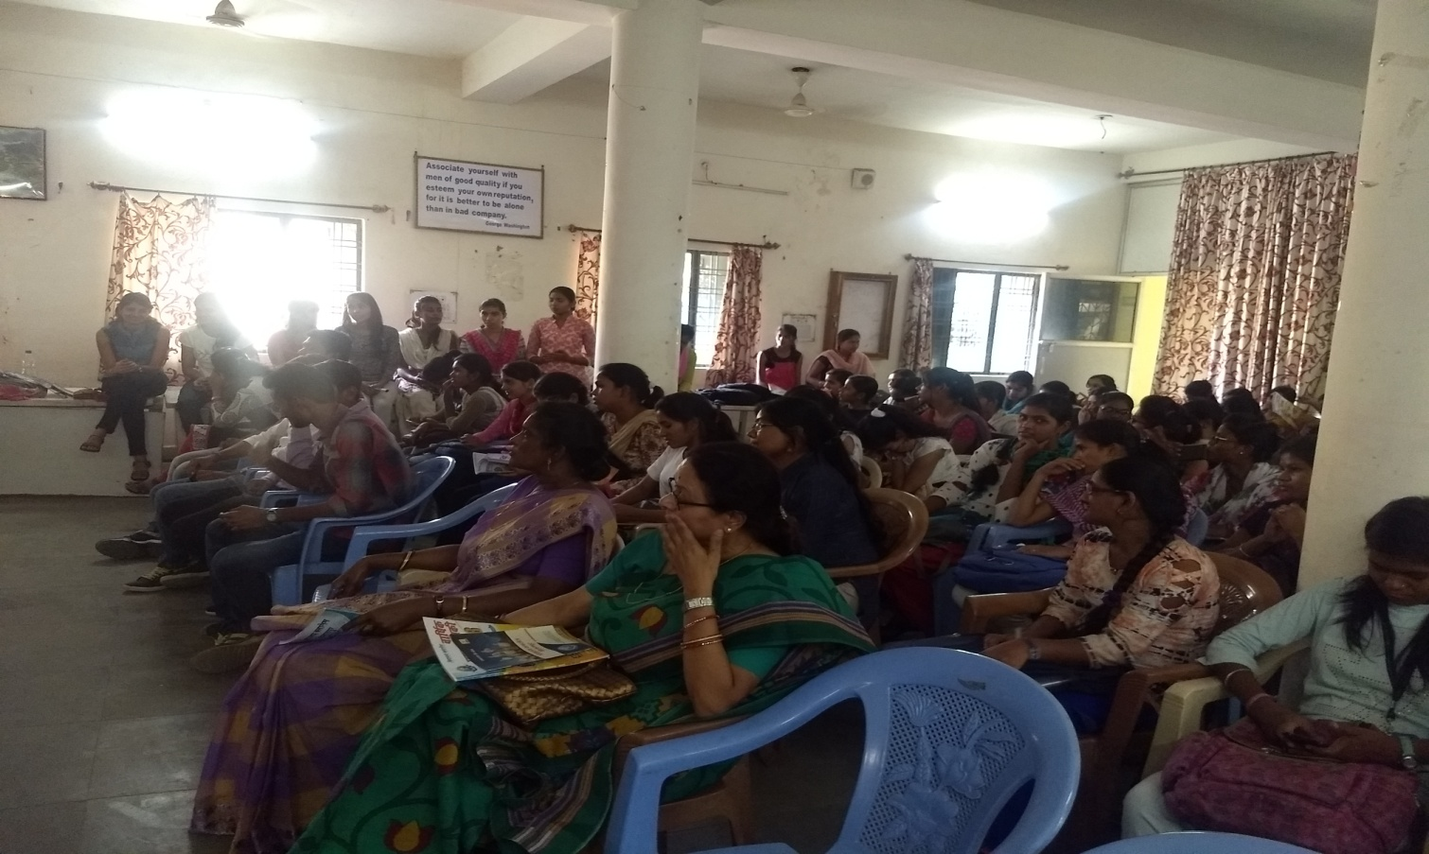
Gathering at the programme

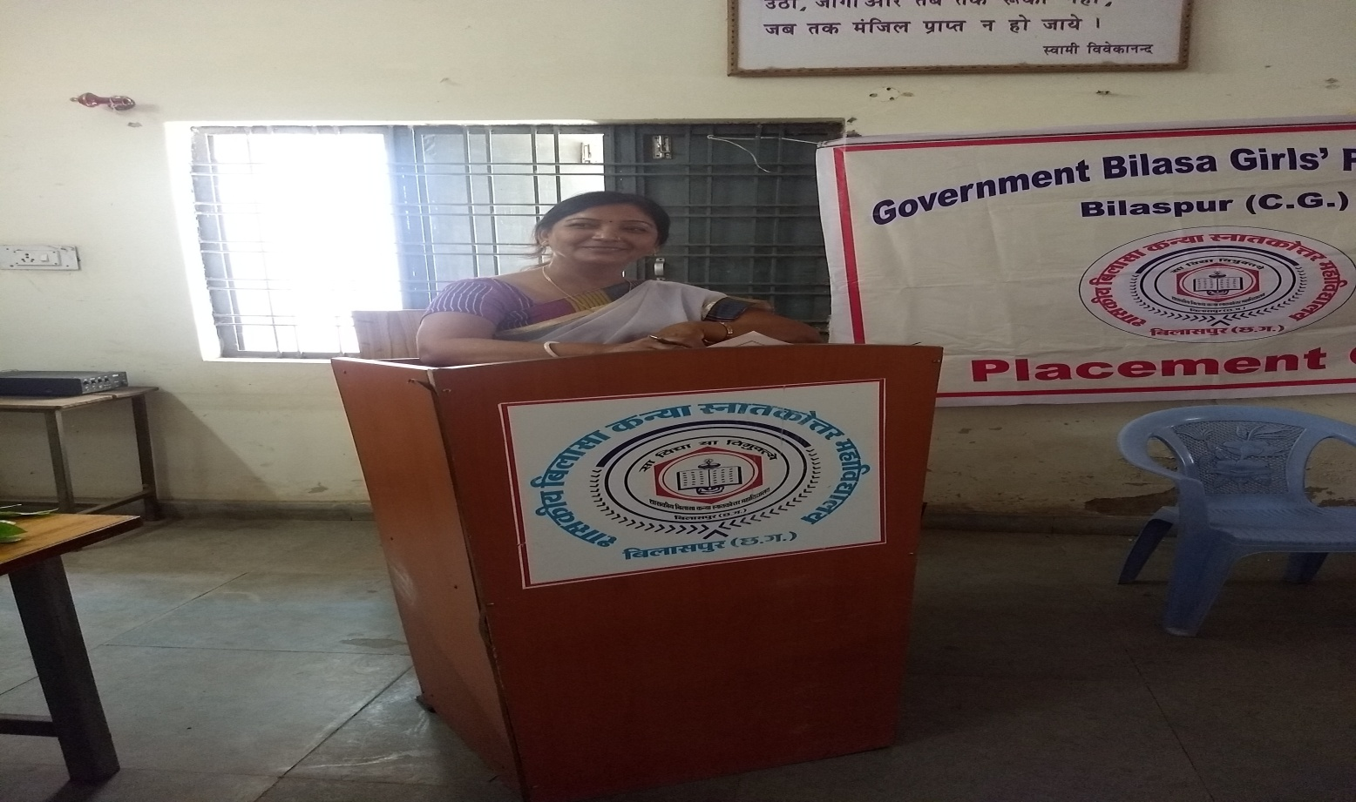
The programme was well conducted by Dr. Manju Madhuri Bajpei

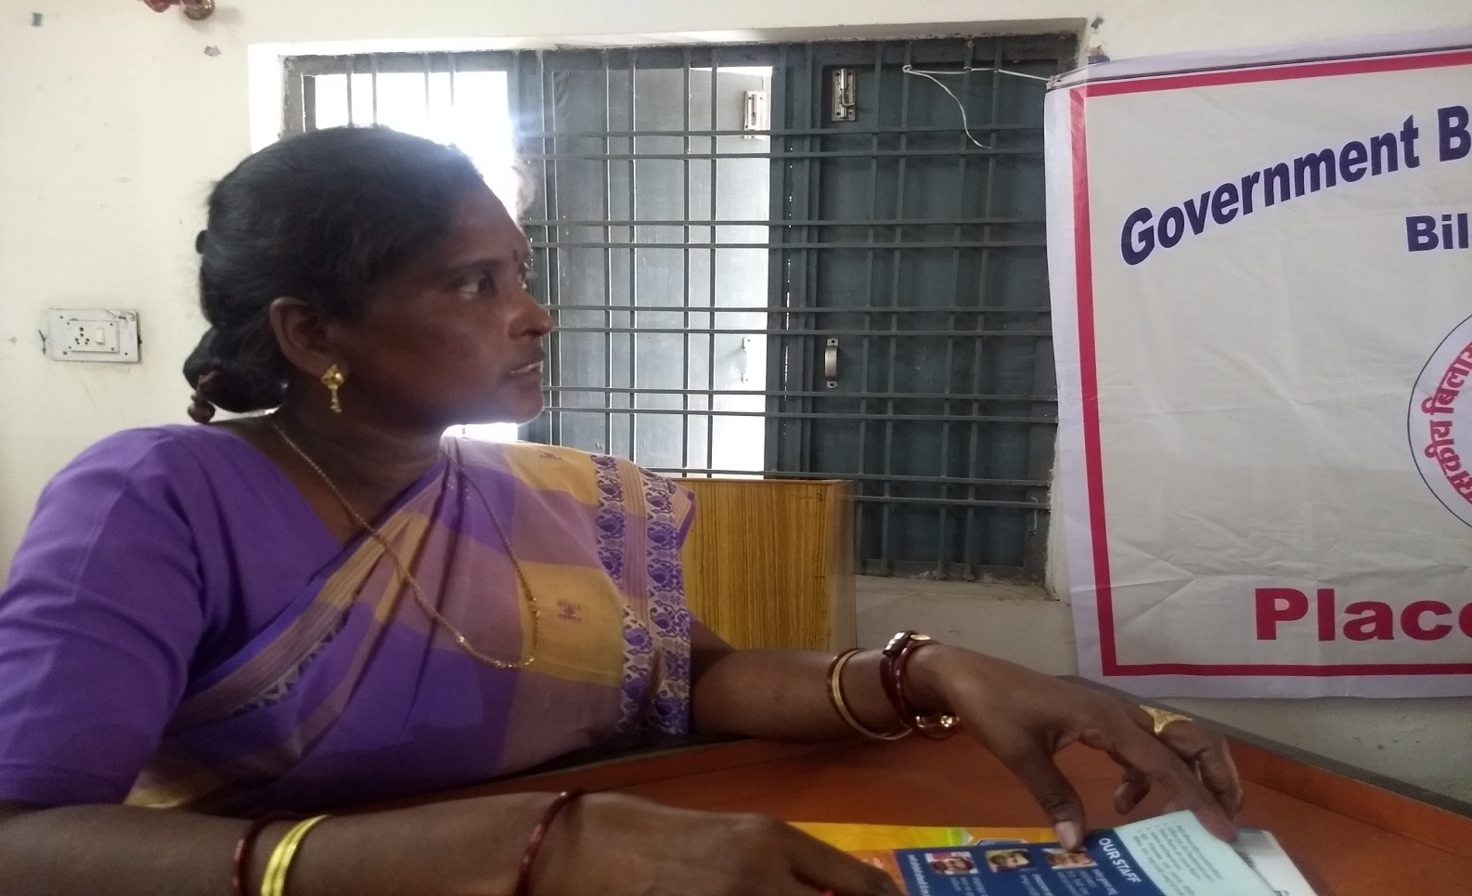
Dr. Sushila Ekka rendering Vote of thanks

TISS (Tata Institute of Social Science) in collaboration with NUSSD (National University Students’ Skill Development Programme) started classes for the students of our college since 7th February, 2018. A notice has been circulated among the students of our college and many students registered themselves for the programme. Faculty wise number of students are- Science Faculty- 66, Arts Faculty- 12, Commerce Faculty- 17, Home Science Faculty- 05, and Computer Science Faculty- 18. Total number of students are- 118.

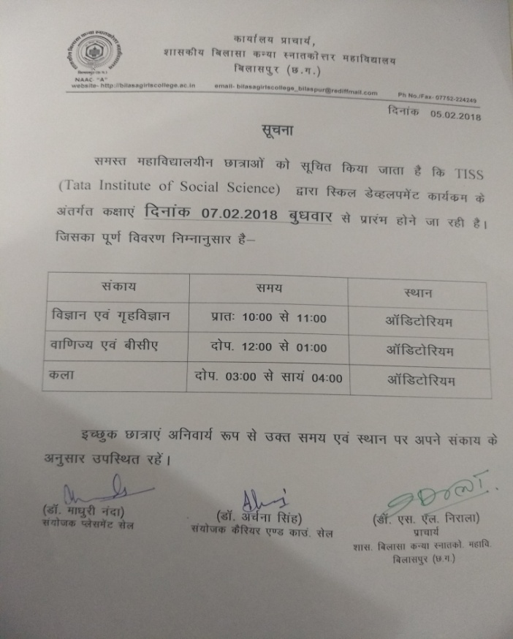
Notice circulated among students

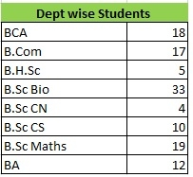

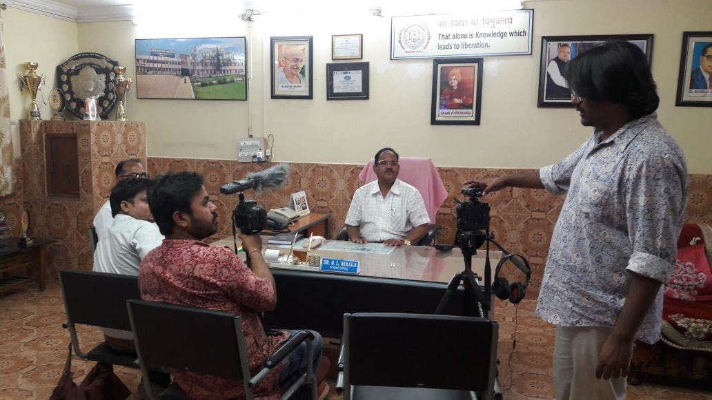
Press Conference by the Principal, imparting information regarding training programme

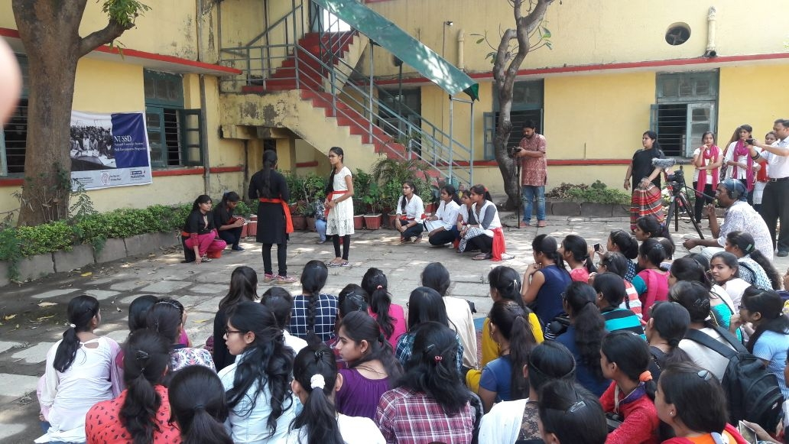
Presentation by the trainee students

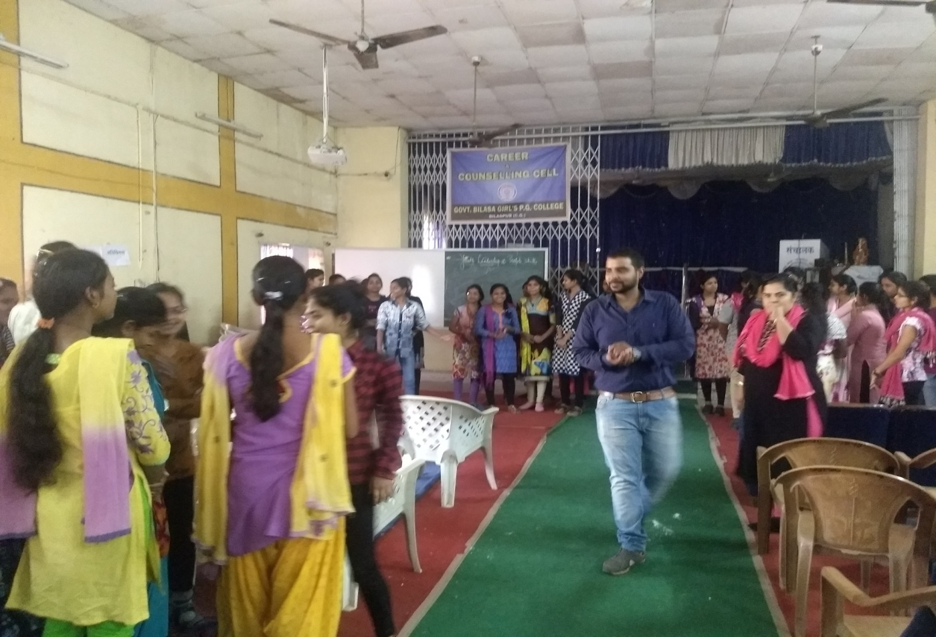
Trainer Sourabh Tiwari during training

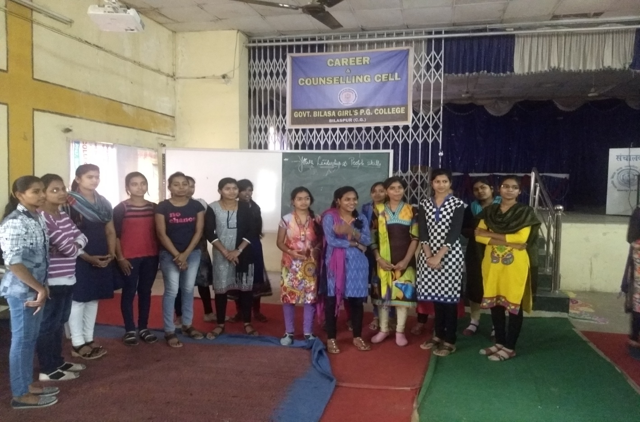
Trainees

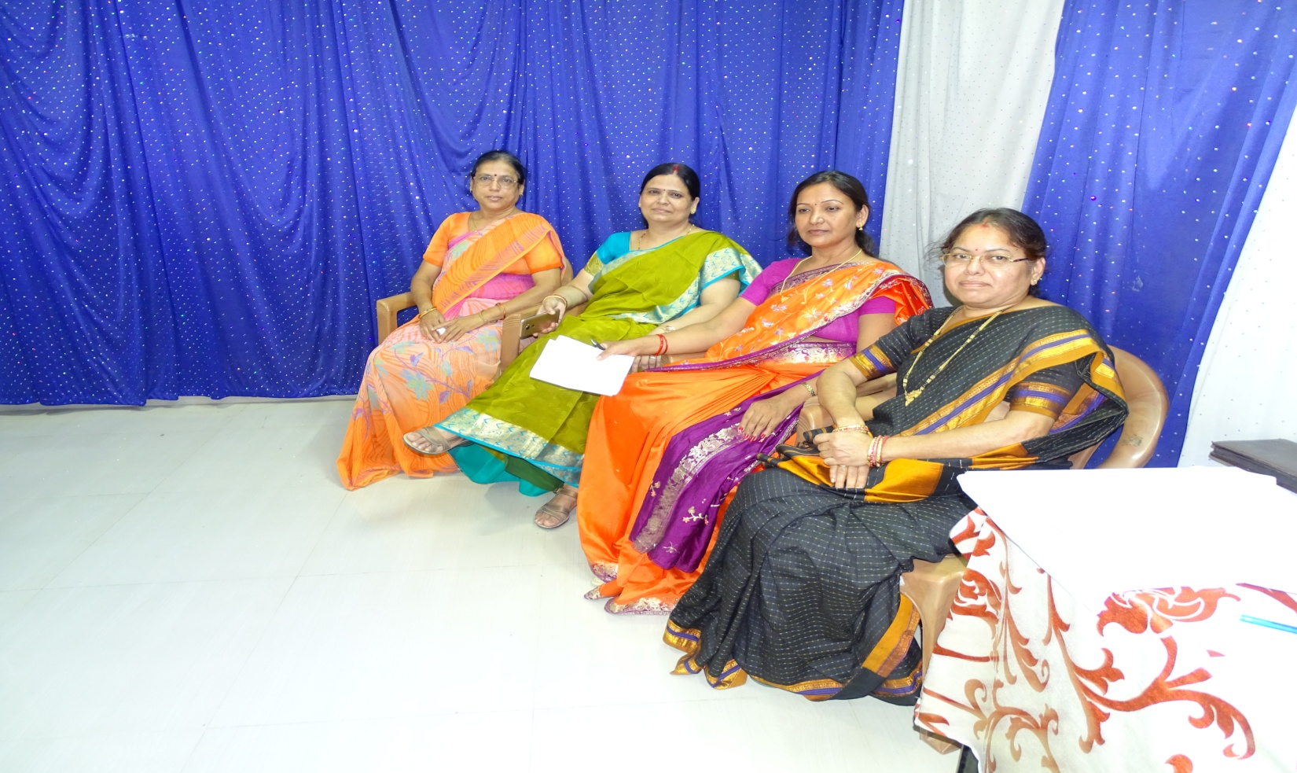
Career & Counselling Cell
‘Success is peace of mind which is a direct result of self-satisfaction knowing you did your best’

Thanks

Website & Front TV Updation
A Report
2017-18

Dr. S. L. Nirala Dr. Archana Singh (Convener)
PRINCIPAL Dr. Aradhana Sharma (Member)

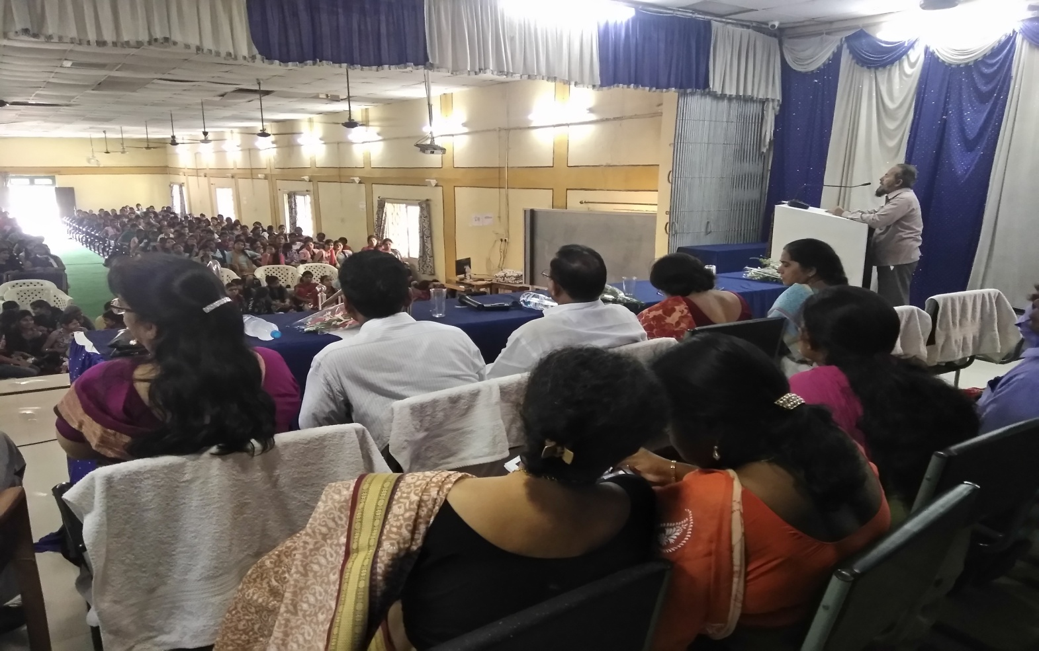
Dr. Khalid Ali addressing the gathering of First Semester

Dr. Mohd. Khalid Ali, Head, Department of Urdu has informed the students of First Semester that the Department of Urdu is one and only department in the state of Chhattisgarh. The department has been serving in the field of Urdu language since 1987 and since then offering various coursess to the students like P.G. in Urdu Literature, at the U.G. level Urdu as a subject and skill based course in Speaking and Writing Urdu.

Website & Front TV Updation
Daily Mail Checking
A Report
2017-18

The Website of our college is www.bilasagirlscollege.ac.in . The website has been conceieved, designed and updated by me in the year 2013. In the year 2017 as per the instruction of then principal it has been outsourced to Ravi Solutions, Durg. College’s day to day activities like Yoga, Vriksharopan, Students’ Election, Oath-taking Ceremony, Social gathering, N.S.S., N.C.C., Nari Sashaktikaran Programme etc. etc. have been uploaded in the website. Besides this Brochure of the college and Faculty information have also been uploaded in the website of the college.
Simultaneously, all the above mentioned activities have also been uploaded in the Front TV of the college.
Daily mail checking work has also been performed by me since 2014. Whether by the Higher Education department or from any Government offices’ or non-governmental offices’ mails have been checked and given to the office of the principal daily. The e-mail address of our college is bilasagirlscollege_bilaspur@rediffmail.com
To perform the above mentioned duties, I have been supported by Dr. Aradhana Sharma, Assistant Professor (Mathematics).

Dr. Archana Singh
In-charge

Career & Counselling Cell
2017-18
A Report

Counselling is a broad term. In the general sense, counselling refers to the process of helping a person by providing guidance, moral support, and exploring solutions for the problems being faced by the students. Counselling is usually associated with a professional helping out an individual in need but in Govt. Bilasa Girl’s P.G. College a cell has been formed to focus on helping one to figure out who you are and what you want out of your education, your career and your life. There are a number of factors that influence students’ career development, including students’ interest, abilities, values, personality, background, and circumstances. This Cell’s aim is more than just deciding on a major and what job you want to get when you graduate.
- At the very outset of the Academic Session an Induction Programme is organized to orient and introduce the new comers viz. First Year’s Students to the various facilities available in the college and also their incharge and the way of their working. This year too, on 22nd & 23rd August, 2017, an Induction Programme has been organized to make the new comers familier with the college activities.
- On 23rd August, 2017 Mr. Narendra Singh from NUSSD, National University of Students’ Skill Development Programme has introduced the students about their Skill Development Programme and the scope of its placement. TISS (Tata Institute of Social Sciences) has taken up the challenge to demonstrate models on skilling people with varying educational qualifications. He also talks about its collaboration with the TISS.
- In the continuation, on 5th September, 2017 Career Guidance Seminar has been organized by the Career Launcher. Mr. Jayesh Gumber has guided the girls that the greatest barrier to success is the fear to failure. The aspirants must first of all to overcome this fear.
- Under the programme of MYSY (Mukhyamantri Yuva Swavalamban Yojna) students have been informed and trained about the interviews and Group Discussion by the Career & Counselling Cell, Dated: 11th November, 2017
- TISS (Tata Institute of Social Science) in collaboration with NUSSD (National University Students’ Skill Development Programme) started classes for the students of our college since 7th February, 2018. A notice has been circulated among the students of our college and many students registered themselves for the programme. Faculty wise number of students- Science Faculty- 66, Arts Faculty- 12, Commerce Faculty- 17, Home Science Faculty- 05, and Computer Science Faculty- 18. Total number of students- 118.
- On 27th of March, Ms. Ayesha Shrivastava from NIBF (National Institute of Banking and Finance) has guided the girls of this college to try in the field of banking and finance. NIBF is a venture with a vision to create a hub of excellence in the field of Banking, Financial Services and Insurance Education in order to fulfill the industry, business requirements and acknowledging the need of the times. In the college, students especially Commerce students have taken keen interest in the programme and asked various questions regarding the advancement of their career.
- A torch bearer is a person who shows the path of success to others and one who himself or herself is successful in the life and achieved the target of his or her life can become the Torch Bearer in its true sense. A programme has been organised on 4th April, 2018 by the Career & Counselling Cell to invite the officials from various fields, selected by the Public Service Commission of Chhattisgarh to share their experiences and their methods pf preparation with the students and what type of obstacles they had to face while preparing for these competitive examinations. This programme caters to the need of aspirants who concerned for their career and future. Invities were Ms. Jaya Patel, Project Officer, Balodabazar, Ms. Sagar Kumar Raj, CMO, Kota, Ms. Deepti Patel, Project Officer, Takhatpur, Mr. Kashav Patel, Nayab Tehsildar, Bemetara and Ms. Shweta Yadav, Nayab Tehsildar, Bilaspur.
- Under the guidance and supervision of Principal, Dr. S. L. Nirala, Govt. Bilasa Girl’s P.G. College, Bilaspur, this Career & counselling Cell has successfully been oraganizing programmes for the welfare of students of this college since 2012 by Dr. Archana Singh, Convener, Dr. Pushpa Bhandari, Dr. Manju Madhuri Bajpei and Dr. Sangeeta Shukla, members of this cell.
- A Report with photographs, news paper’s cutting and notices circulated among the students has been submitted to the Office of the Principal at the end of the session 2017-18.

Dr. Archana Singh
Convener
Career & Counselling cell
Govt. Bilasa Girls’ P.G.College
Bilaspur (C.G.)

